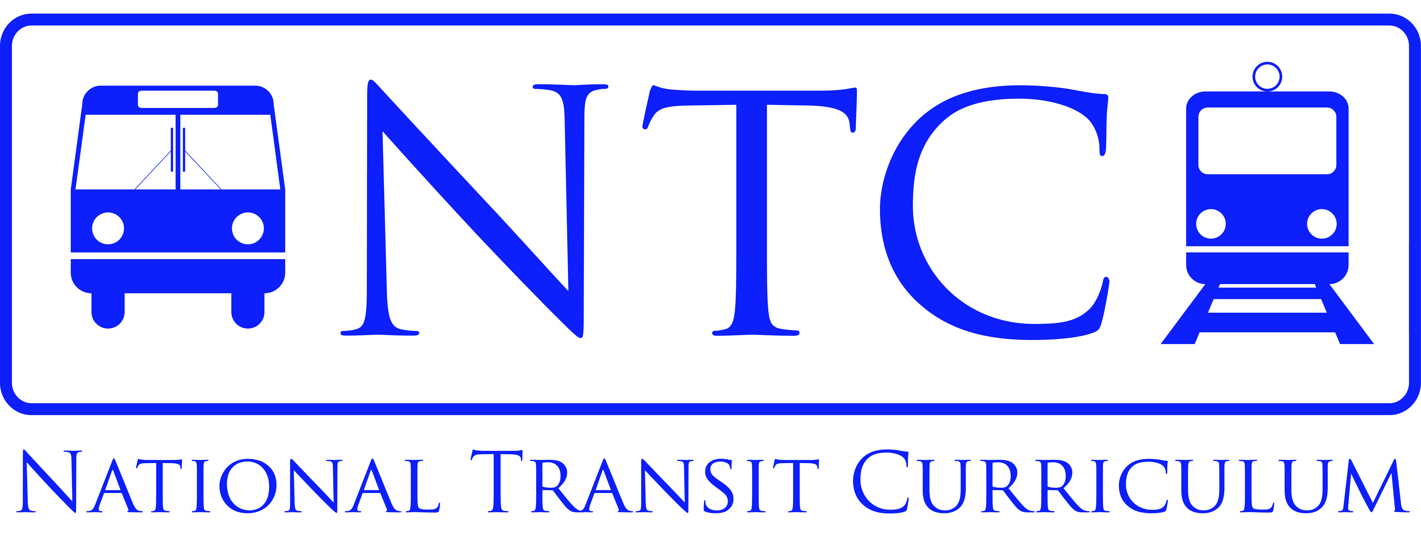

How To Use This Curriculum

This curriculum is aimed at graduate students, but may be for undergraduates as well.

The curriculum was developed by a team of individuals from public transit agencies, private sector transit firms, trade associations, Federal agencies and academic institutions. The curriculum is intended to provide students with a basic understanding of the public transportation industry, increase their interest in the industry, and prepare them to enter careers in the industry. This effort was voluntary and represents a strong desire by the committee to address a gap in the knowledge that is available in institutions of higher education regarding this important element of our transportation network.

This curriculum may be used in its entirety to create a semester-long course on public transportation. If a semester-long course is not desired, individual modules can be selected to provide an overview of public transportation and used to supplement other courses.

For all of the modules, PowerPoint slides are provided for class lectures. These slides can be modified to address specific objectives that instructors may want to achieve in their classes. All slides have instructor notes unless the particular slide is self-explanatory. Where appropriate, references to articles, reports and texts have been provided to allow the instructor to make student reading assignments. Several assignments are also provided.

It is up to the individual instructor to determine how to use the materials. The curriculum was designed so that it can be adapted to all learning situations.

While the data provided in this curriculum was up-to-date and most recent when it was developed, the data is fluid and will change over time. The instructor using these materials should determine if the data fits their needs or should be updated. References to the data sources have been provided where appropriate.

In using these materials, we ask that acknowledgement be given to the National Transit Curriculum.

