INTRODUCTION
Over the past two decades, the American Public Transportation Association (APTA) has developed and updated its Standard Bus Procurement Guidelines – popularly known as the White Book – to provide transit agencies with a consistent set of commercial terms and technical specifications for the procurement of transit buses. As technologies and propulsion systems have evolved, the White Book has grown to include new technologies and options that bus manufacturers offer to their customers. This can make it challenging for transit agency procurement officers to select the technical specifications and commercial terms most appropriate for the propulsion systems and technologies they seek to procure.
To simplify the procurement process, APTA has automated the White Book for use in procuring transit buses using diesel, hybrid, CNG, battery-electric, and hydrogen fuel cell technologies. This will enable a transit agency to order, for example, a battery-electric 40-foot bus that includes all required provisions (and choices desired by the agency) and excludes those pertaining to buses using different propulsion technologies.
The automated specification – which essentially uses a “mail merge” approach for procurement officers to select specific technical options – consists of several documents:
- Inputs: There are two Excel spreadsheets used to add data across the documents and to make specific selections regarding commercial provisions and technical specifications. The spreadsheets include the provisions, optional selections, explanations, and the complete language from the White Book.
  - RFP and Commercial Terms: An Excel spreadsheet used to populate specific agency information across the procurement documents and to select key commercial terms.
  - Technical Specifications: An Excel spreadsheet used to select from 250 “default” or “optional” technical provisions relating to all elements of the bus.
- Populated Documents: A resulting set of Word documents reflecting the inputs provided in the Excel spreadsheets. The final Word documents can be further edited to add or revise the commercial terms and technical specifications as desired by the procurement staff.
Below are two sets of instructions, one explaining the overall flow of the approach and the other with specific instructions on how to create the mail merge documents using the Excel spreadsheets for both the RFP/Commercial Terms and the Technical Specifications.

The Big Picture and Overall Flow
Once you have decided on the desired propulsion type for your buses, you will receive a ZIP file containing six items. Unzip the files and save the results. You will see the following items.
- Two Excel files:
  - One for inputs and selections related to the RFP and commercial terms
  - One for inputs and selections related to the technical specifications
Each row of the Input sheet in these Excel files contains variables that will populate your contract.
- Two Word template documents:
  - One for commercial terms
  - One for technical specifications
These templates contain standard language that is not expected to change between contracts. They also include bookmarks and placeholder fields that are automatically filled based on your input selections in the Excel files.
- A checklist to guide you through the process and help you verify the generated documents.

Workflow
- Start with the Commercial Terms
- Open the inputs_non_technical.xlsx file.
Begin by reading the Introduction and Instructions sheets. The Introduction sheet prompts you to select the propulsion type of your buses.
- The Input sheet is where you will spend most of your time configuring selections for your contract. Each row in this sheet represents a clause or section of the contract that can be modified. You can use the Used in Section(s) column to see where each input will apply in the Word template.
Tip: Open the template_doc_non_technical document side-by-side with the Excel input sheet—ideally on a second screen. This allows you to track how your inputs will affect the document visually.
!!!Do not modify the template document directly.!!!!! You will be able to edit the final document, starting at step 10 below.
- Carefully go through each row. Some rows require manual entry (e.g., specific requirements), while others offer pre-filled options or drop-downs. Some require both. Use the Questions, Notes, and Suggestions columns as guidance. Additional notes may appear as comments or tooltips when you hover over specific cells. For more complex cases, example entries are provided.
- Once satisfied with your entries, save the Excel file and close it and the template Word document.
- Configure Technical Specifications
- Repeat the same process with the technical documents. Open:
  - inputs_technical_[your propulsion type].xlsx
  - template_doc_technical_[your propulsion type].docx
- Again, place them side-by-side and go through the input rows. The technical section contains nearly twice as many entries, so you may want to complete it in multiple sessions. Be sure to save your progress frequently.
- Merge Inputs into Template Documents
- Once you’ve completed both Excel input files, follow the instructions in the Import Inputs to Contract Template with Mail Merge section.
- After generating the two customized Word documents, save them with your desired file names.
- Then, combine the documents by selecting the entire content of the technical specification document using Ctrl+A, copying it, and pasting it into the commercial terms document at the end of Section 5, just before Section 7. Use Keep source Formatting when pasting to maintain a consistent style.
- Review and Finalize the Document.
  - All content imported from Excel will appear in red font.
Review each red entry and change the font color to Automatic or black once confirmed.
  - Check for formatting consistency—ensure symbols, lists, and indentation appear as expected.
  - Some parts of the document may require
    - Images
    - Logos
    - Tables
    - Additional forms or appendices
These are noted throughout the document and/or listed in the checklist.
  - Consult the checklist for any remaining items
- Use the checklist to ensure all content is correctly inserted and all required elements are present.
- Once complete, update the Table of Contents to reflect the final structure. Delete the current table of contents and use the References tab to create a new one.
- Your contract document is now ready for submission or internal review.

Import Inputs to Contract Template with Mail Merge
This guide walks you through how to use Microsoft Word’s Mail Merge feature to generate personalized contract documents using the provided files:
- Excel file: inputs_non_technical.xlsx (or alternatively the inputs_technical_[your propulsion type] if you are merging the technical specifications)
- Word template: template_doc_non_technical.docx (or alternatively the template_doc _technical_[your propulsion type] if you are merging the technical specifications)
If you rename any of your files, make sure to refer to the updated name during the Mail Merge.
⚠️ Note: This is part 1 of 2. After completing this process, repeat the same steps using the technical versions of the input and template files.
For additional information and guidance on how Mail Merge works, you can consult Microsoft support articles.

Before You Begin
Before conducting the Mail Merge, make sure to check the following:
- Both files (inputs_non_technical.xlsx and template_doc_non_technical.docx) are saved in the same folder.
- Excel file is closed before starting the merge.
- You know whether you're using Windows or Mac.

Mail Merge Instructions for Windows
Follow the steps below to bring your input to the contract template:
Step 1: Open the Word Template
- Open template_doc_non_technical.docx in Microsoft Word. Check that the document is editable and is not in “Read-Only” mode. If it is, save a copy to your own files to enable editing.
Step 2: Start the Mail Merge
- Go to the Mailings tab.
- Click Start Mail Merge → choose Normal Word Document. (Figure 1)
Figure 1: Start Mail Merge
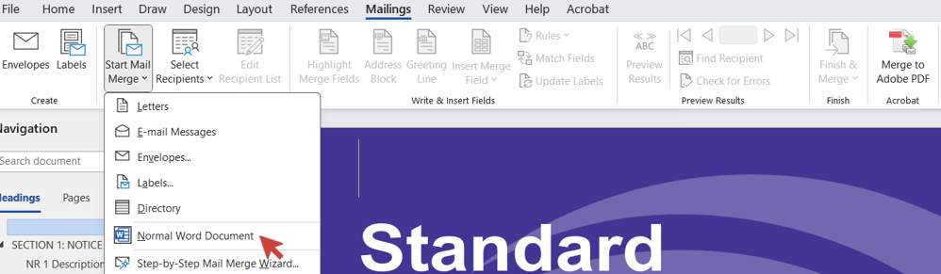
Step 3: Connect the Excel File
- Click Select Recipients → choose Use an Existing List... (Figure 2)
Figure 2: Select Recipients 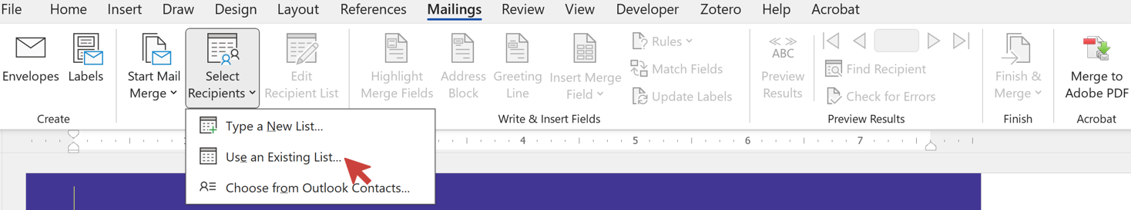
- Browse to and select inputs_non_technical.xlsx (or the other input file)
- If prompted, choose Use for Word doc$) sheet and click OK. (Figure 3)
Figure 3: Select Table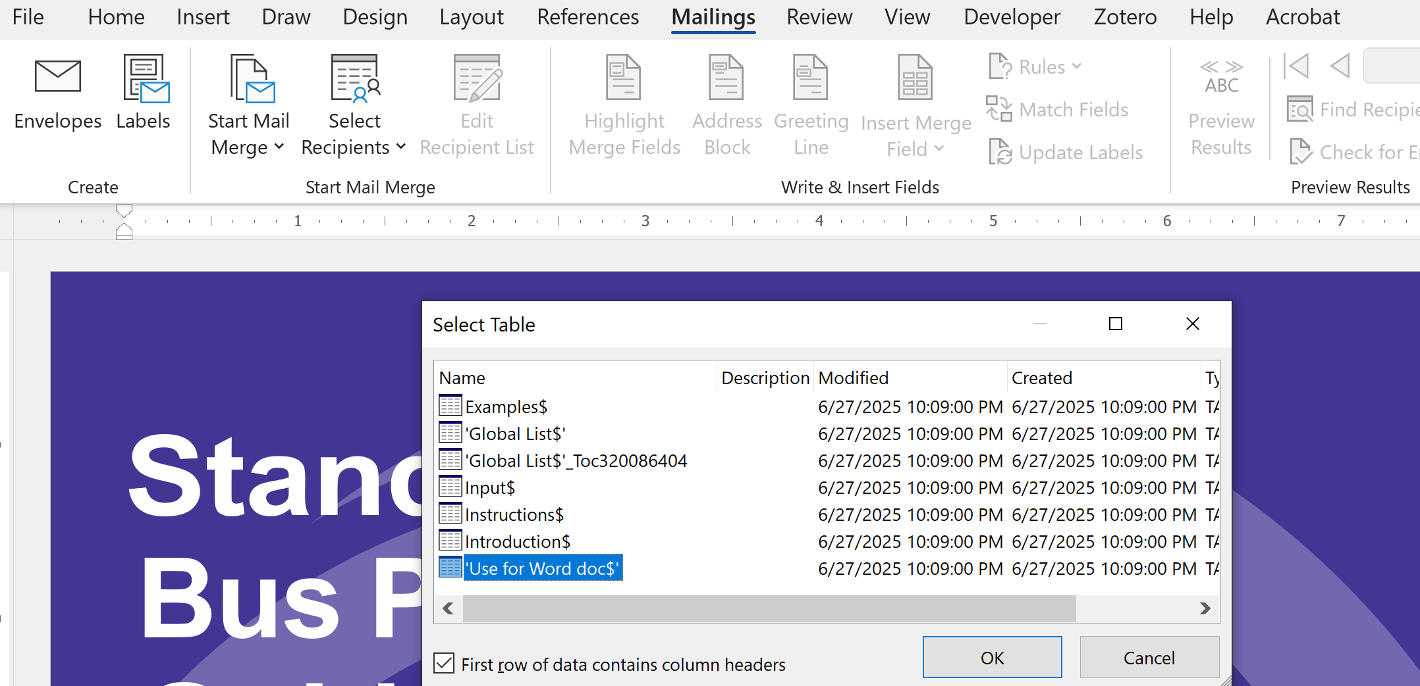
Step 4: Preview the Results
- Click Preview Results to review how each contract will look.
- Use the arrow buttons to scroll through records.
Step 5: Finish & Generate the Documents
- Click Finish & Merge.
- Choose Edit Individual Documents... (Figure 4)
Figure 4: Edit Individual Documents 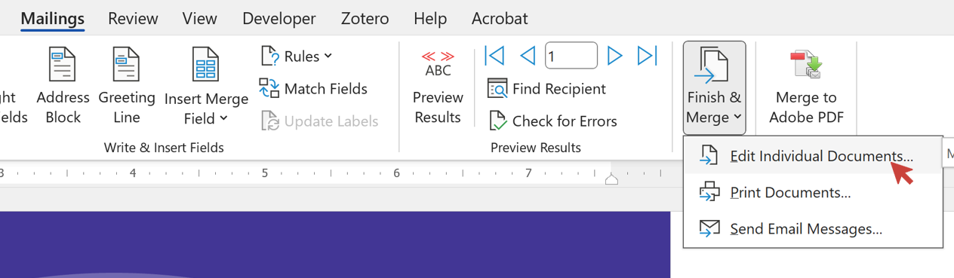
- In the dialog that appears, select All and click OK. (Figure 5)
Figure 5: Merge to New Document
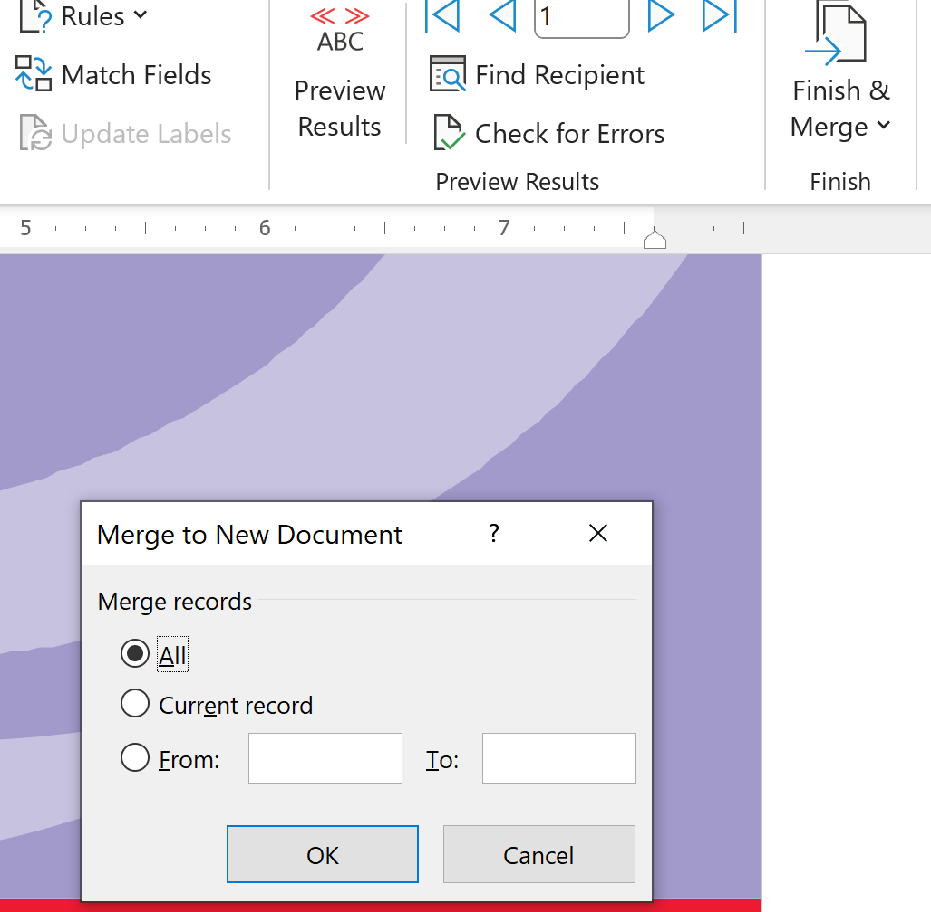
- Word will generate a new document with all merged contracts.
Step 6: Modify and Revise
- You can now perform a final review to ensure the contract meets your needs. You can make any additional changes directly in the document, including adding images, appendices, or adjusting the languages as necessary.
Step 7: Rename and Save
- Name your file and save (It is recommended to include the date you worked on the contract in the name for version control).

Mail Merge Instructions for Mac
Follow the steps below to bring your input to the contract template:
Step 1: Open the Word Template
- Open template_doc_non_technical.docx in Microsoft Word.
Step 2: Start the Mail Merge
- Go to the Tools menu → select Mail Merge Manager.
- In the Mail Merge Manager panel:
  - Under Select Document Type, choose Form Letters.
  - Under Select Starting Document, click Use the Current Document.
Step 3: Connect the Excel File
- Under Select Recipients List, click Get List → Open Data Source…
- Select input_non_technical.xlsx.
- Choose the sheet (i.e., Use for Word Doc) when prompted, then click OK.
Step 4: Preview the Results
- Under Preview Results, use the arrows to see how the merged content looks.
Step 5: Complete the Merge
- Under Complete Merge, click Merge to New Document.
- Choose All records and click OK.
Step 6: Modify and Revise
- You can now perform a final review to ensure the contract meets your needs. You can make any additional changes directly in the document, including adding images, appendices, or adjusting the languages as necessary.
Step 7: Rename and Save
- Name your file and save (It is recommended to include the date you worked on the contract in the name for version control).

