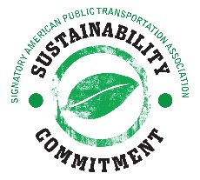

Sustainability Commitment Signatory Application

Transit Agencies

My organization, __________________________________________________, a member of the American Public Transportation Association (APTA), intends to continually improve its sustainability practices and fulfill the core principles of the APTA Sustainability Commitment, as follows:

- Make sustainability a part of my organization’s strategic objectives
- Identify a sustainability champion within the organization coupled with the proper human and/or financial resources and policies
- Conduct employee outreach to engage staff on:
- how they can help realize the organization’s sustainability goals;
- the organization’s progress in meeting those goals.
- Develop a sustainability inventory of my organization
- GHG emissions (Scope 1, 2)
- Energy use (electricity, fuel)
- 3 of the following environmental indicators:
  - Water usage
  - GHG savings
  - Recycling levels/waste
  - Percent of electricity that is renewable
  - Criteria air pollutant emissions (PM 2.5, CO, NOx, HC)
- 2 of the following social/economic indicators:
  - Percentage of vehicles or stations/stops that are ADA accessible
  - Number of discounted fare programs – for schools, seniors, disadvantaged, indigenous/native, etc.
  - Or any metric listed in TCRP Report 205: Social and Economic Sustainability Performance Measures for Public Transportation

Within one year of signing, my organization will give a progress report of steps made to achieve the core principles.

Name and position of person empowered to sign on behalf of organization:

__________________________________________________________________________

Signature and date: _________________________________________________________

Contact person/email (if different from above):

__________________________________________________________________________

Please send application forms to the attention of Christina Jung by email to cjung@apta.com

