ATPA Systems Engineering Subcommittee
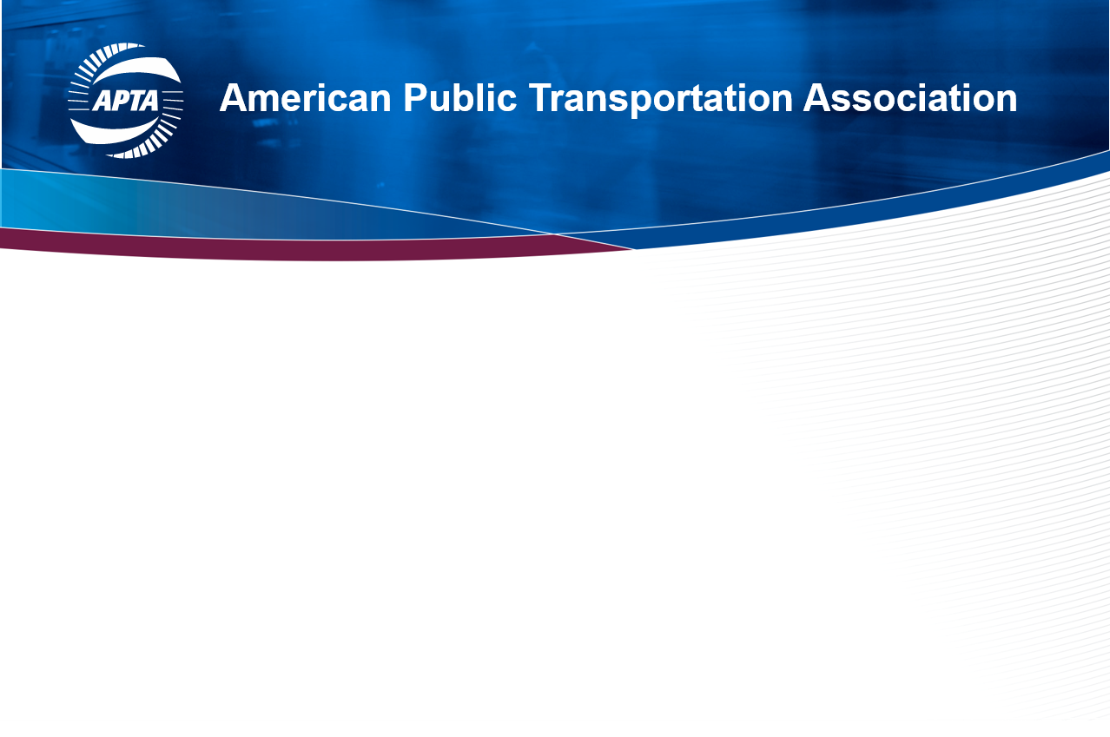
Saturday, June 4, 2022
3:30 – 5:00 p.m. PST

Room: Indigo 202, Indigo Level, Hilton Bayfront

AGENDA

1 | Welcome and Introduction
2 | Summary of the Topics from last year
3 | Project Status: ‘APTA Systems Lifecycle Engineering’ product
4 | Transit Systems Engineering Presentation
5 | Roundtable Discussion
 | Topic/Theme(s) for the committee for the next year
 | (What would members like to see the committee working on?)
8 | Next SE Subcommittee Meeting
9 | Adjourn

