D

COMMUTER RAIL COMMITTEE
June 5, 2022 – 12.00 PM to 1.30 PM Pacific Time
Sapphire Ballroom D, Sapphire level
Chair, James Derwinski; Executive Director - Metra
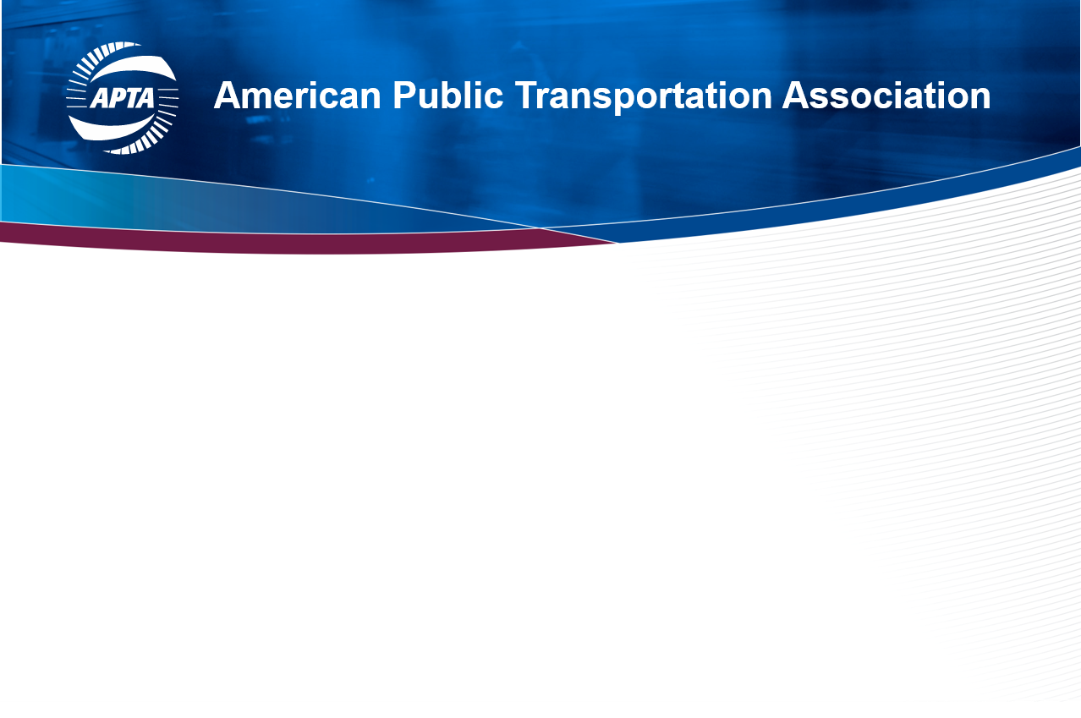
AGENDA

12:00 pm Welcome and Call to Order Jim Derwinski (Metra)

12:05 pm Round the Table Agency Reports Present Agencies
- Ridership (holistic number)
- Projects (in the next 2-3 years)

12:25 pm FRA Update Allison Ishihara Fultz (FRA)
Report Outs

12:35 pm Legislative Subcommittee Stacie Tiongson (APTA)

12:40 pm Safety and security subcommittee Gardner Tabon (Capital Metro)

12:45 pm Chief Operating Officers Subcommittee Justin Vonashek (MTA NY MNR)

12:50 pm Commuter Rail workshop Jim Derwinski (Metra)

01:00 pm Business Member Engagement Jim Derwinski (Metra)

in Supporting Committee Activities

01:10 pm APTA Benchmarking with Imperial College Narayana Sundaram (APTA)

01:20 pm FRA Rail Safety Advisory Committee Report Narayana Sundaram (APTA)

Next meeting - TBD
- MISSION STATEMENT
This committee promotes commuter railroads and works to address their unique regulatory, legislative, and operational issues. The Commuter Rail Committee, is working on a very active agenda including:
- Enhancing the ability of passenger railroads to access freight railroad rights of way;
- Establishing Passenger Rail Standards and Recommended Practices; and
- Strengthening the Commuter Rail System Safety Program.

