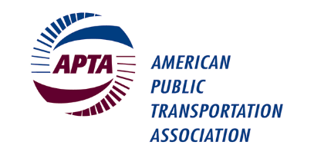
Bus Operations Committee Meeting

APTA Mobility Conference
Hyatt Regency Columbus
2nd Floor Franklin A-B Room
Sunday, May 1st, 2022, 8:30 – 9:30 a.m.
(continental breakfast will be available)

Please check the room location onsite as room assignments can change.

Please bring your own copy of this meeting agenda as hard copies will not be provided. Thank you.

Committee Officers: Chair: Shawn Donaghy, C-Tran
Vice Chair: Herold Humphrey, MARTA
Secretary: Dawn Distler, METRO RTA

Staff Advisors: Lisa Jerram (ljerram@apta.com)

Presiding: Shawn Donaghy, Chair

MEETING AGENDA

- Welcome and Introductions – Shawn Donaghy, Chair (10 min)

- Two Presentations by the American Bus Benchmarking Group (20 min)
- Changes in level of service since COVID: a discussion of impacts on ridership and performance
- On demand service: brief overview of services agencies being trialled and ideas of how to best measure success
- Presenters:
  - Mark Trompet, Associate Director and Head of Bus Benchmarking, Transport Strategy Centre, Imperial College
  - Lindsey K. Morse, Senior Research Associate, Transport Strategy Centre, Imperial College, and Project Manager, American Bus Benchmarking Group

- Election 2022 Results and Hand-Off to New Officers (15 min)

- Open Forum – Top Topics/Issues for Bus Operations Committee in 2022-2023 (15 min)

- Adjourn

Note that this agenda may be subject to change.

