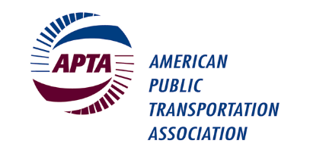
Bus & Paratransit CEOs Committee Meeting

APTA Mobility Conference
Hyatt Regency Columbus
2nd Floor Franklin A-B Room
Sunday, May 1st, 2022, 12:00 – 1:30 p.m. EST

Please check the room location onsite as room assignments can change.

Please bring your own copy of this meeting agenda as hard copies will not be provided. Thank you.

MEETING AGENDA

Presiding: Karen King, Chair

- Welcome and Introductions – Karen King, All (5 min)
- Greetings from APTA Leadership (5 min)
- Legislative Update – Ward McCarragher, APTA Vice President, Government Affairs and Advocacy (10 min)

- Emerging Leaders Presentation: Ridership Recovery (15 min)
- Bylaws Review (15 min)
- Officer Elections (10 min)
  - Presentation of new officer slate
  - Voice vote
- Open Forum – All invited to raise topics of interest (15 min)

- Adjourn

Note that this agenda may be subject to change.

