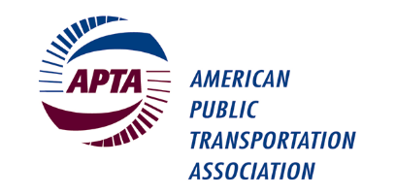
Bus Technical Maintenance Committee

APTA Mobility Conference
Hyatt Regency Columbus
2nd Floor Franklin A-B Room
Sunday, May 1st, 2022, 4:00 – 5:00 p.m.

Please check the room location onsite as room assignments can change.

Please bring your own copy of this meeting agenda as hard copies will not be provided. Thank you.

Officers: Chair: Jerry Guaracino, WMATA
Vice Chair-Webinars: Obed Mejia, LA Metro
Secretary: Geoff Lawrence, Fraser Gauge
Staff Advisor: Lisa Jerram, APTA (ljerram@apta.com)

Presiding: Jerry Guaracino, Chair

MEETING AGENDA

- Welcome and Introduction of Officers – Jerry Guaracino, Chair (5 min)
- Self-Introductions (if time permits) - (10 min)
- Update on Committee Activities:
  - Bus Maintenance Webinars – Obed Mejia (5 min)
  - Brake & Chassis Standards – Geoff Fraser (10 min)
- Reminder of Officer Elections for 2023 – Jerry Guaracino (5 min)
- Update from International Transportation Learning Center on ZEB training (10 min)
- Open Forum (remainder of time)

- Adjourn

Note that this agenda may be subject to change.

