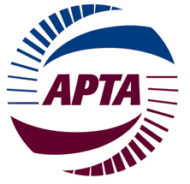
AMERICAN PUBLIC TRANSPORTATION ASSOCIATION
BUSINESS MEMBERS

Programs & Communications Committee

June 5, 2022
2022 APTA Rail Conference
San Diego, CA

Room to be determined
11:00 am – noon (Pacific)

TIME | TOPIC | SPEAKER
11:00 am | Welcome | Jim LaRusch, Vice Chair
11:05 am | Committee charter and functions | Communications (newsletter) – Emily Guill  Speakers (conference/event programming) – Jim LaRusch  Awards development – Christina Belmont  Annual meeting – Lindy Norris
11:15 am | Upcoming events and meetings | Jim LaRusch
11:20 am | Business Member Annual Meeting – promotion, dates, location, registration | Lindy Norris
11:30 am | Communications update and discussion of rebranding the newsletter | Emily Guill
11:40 am | Planning cycle for speakers and conference sessions | Jim LaRusch
11:45 am | Awards update | Christina Belmont
11:55 am | Other business | Jim LaRusch
noon | Adjourn

NEXT IN PERSON MEETING of the Programs and Communications Committee: OCTOBER 9, 2022
APTA Transform Conference, Seattle, WA

