Fare Collection Systems Committee Meeting
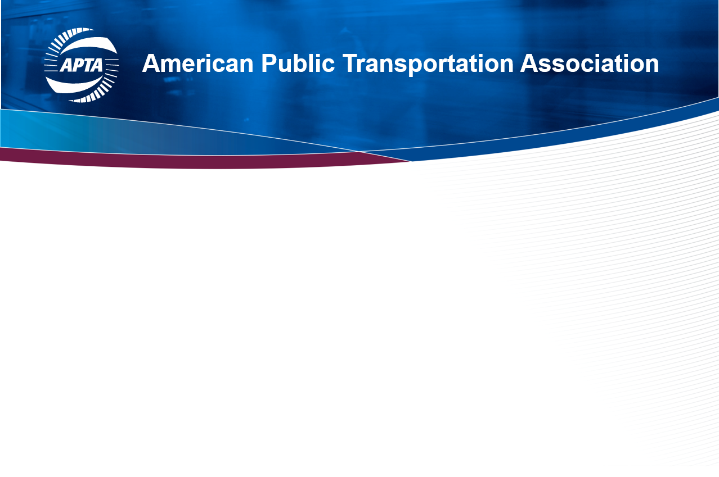
Sunday, May 1, 2022
9:00am – 10:30am
Delaware C-D, Second Floor, Hyatt Regency Columbus

AGENDA

Welcome | Christina Belmont
Introduction to new FCSC Staff Advisor  Introduction of Executive Committee Leaders  Present / obtain acceptance of minutes  Introduce Free Fare Subcommittee  Announcement of fare collection professionals’ promotions, retirements, etc. | Christina Belmont  Mike Veltri  Alex Litchfield  Christina Belmont / Alex Litchfield  DeeNaye Williams / Eugene Reed
APTA Update  APTAtech Update | Eugene Reed / DeeNaye Williams  Eugene Reed / Bonnie Crawford / Sheri Dixon
Featured Presentation Introduction  Featured Presentation - Please come back: how agencies are changing fares to meet evolving needs and grow ridership  Next Meeting – July 21, 2022 via Zoom  Adjourn | Christina Belmont  Antoine Belaieff – FAIRTIQ, Bonnie Crawford – Umo, Liz Smith - SEPTA  Christina Belmont  Christina Belmont

