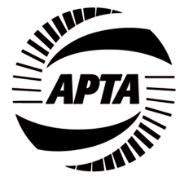
APTA Information Technology (IT) Committee Meeting

In Person at APTA Mobility Conference in Columbus, Ohio

10:30 am – 12:00 Noon EST

Sunday, May 1st, 2022, Hyatt Regency

Chair: David Jackson, TransTrack Systems, General Manager
Vice Chair: Steve Young, VIA Metropolitan Transit, VP of Technology & Innovation

Agenda
- Welcome and Introductions​
- March Meeting minutes
- APTA​ Update
- RoundTable – Sharing about: Name, Position, Agency (or Company), Cool thing to share
- RoundTable Discussion – Key industry needs that your agency is looking to solve in the next 18 months?
- Solicit topic ideas or ideas for speakers for future meetings with the membership
- Next IT Sub-Committee Meeting: August – at APTA Tech Conference, Denver, August 14th

