

**American Public Transportation Association**

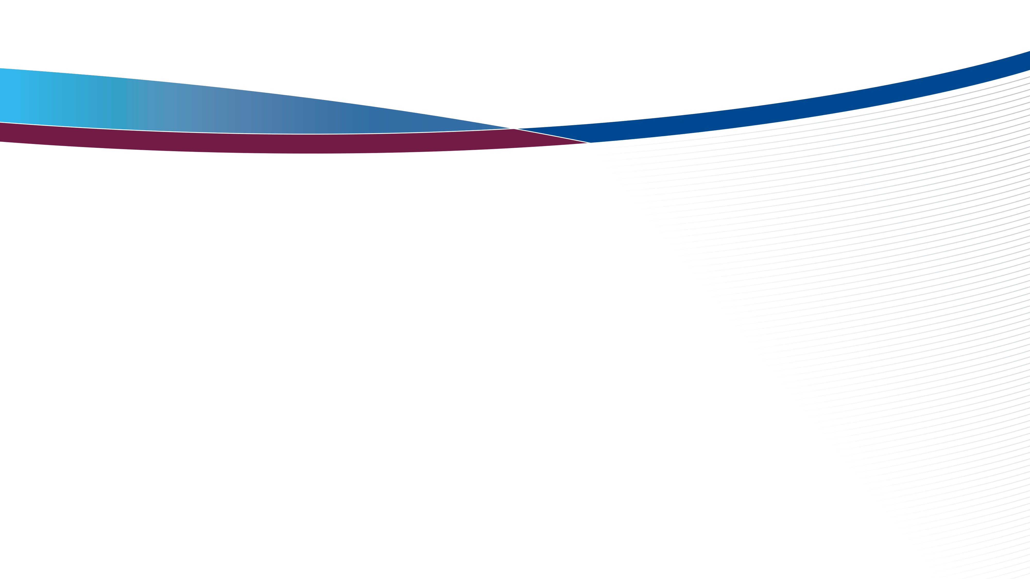

### **Commuter Rail COOs Subcommittee Meeting**

**Sunday, Jun 05, 2022, 3.00 PM Pacific Time**

Sapphire 410, Sapphire Level, Hilton Bayfront

**AGENDA**

1. Welcome and Quick Introductions
2. Regulatory Efforts from FRA & DOT
   1. Crew Size Rule and APTA efforts (5 minutes)
   2. Signal men and Dispatcher certification (5 minutes)
   3. Forward facing glazing NPRM (5 minutes)
   4. TSA Rule on Vetting Surface Transit Employees (5 minutes)
   5. Upcoming RSAC meeting - June 27th 2022
3. ENS Signs discussion – Dale Davidson, FRA, Office of Safety (10 minutes)
4. CROG Overview and Update – Bruce Cardon, UTA (5 minutes)
5. Formalize work plan and efforts for 2022-23 (30 minutes)
6. Workforce issues discussion – Justin Vonashek, MNR (15 minutes)
7. **Open Discussion:** Provide an opportunity for attendees to discuss any relevant topics as well as new agenda topics for future meetings.

1. **Adjourn**