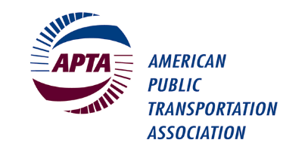
Mid-Size Operations Committee Meeting

APTA Mobility Conference
Hyatt Regency Columbus
2nd Floor Franklin A-B Room
Sunday, May 1st, 2022, 1:45 – 3:00 p.m. EST

Please check the room location onsite as room assignments can change.

Please bring your own copy of this meeting agenda as hard copies will not be provided. Thank you.

Committee Officers: Chair: Dawn Distler, METRO RTA
Vice Chair: Shawn Donaghy, C-Tran
Secretary: Miguel Velazquez, RTS

Staff Advisors: Lisa Jerram, APTA (ljerram@apta.com)

Presiding: Dawn Distler, Chair

MEETING AGENDA

- Welcome and Introductions – Dawn Distler, Chair (10 min)

- Workforce Challenges – Led by Dawn Distler (45 min)
This committee has agreed that workforce / labor is the top issue that members want to address in the coming year.

Please come prepared for a working session, led by the committee officers, where committee members will establish 2-3 sub-groups that will each focus on a particular aspect of the workforce challenge and will agree to meet regularly in the next 12 months to produce deliverables that can help APTA members with this issue.

- Mid-Size Operations 2022 Meeting Schedule (5 min)
  - June 2, 3-4 pm ET (virtual)
  - August 4, 3-4 pm ET (virtual)
  - October 9 (in person @ APTA Annual)
  - December 1, 3-4 pm (virtual)

- Open Forum – All attendees invited to raise other topics (10 min)

- Adjourn

Note that this agenda may be subject to change.

