Proposed National
Public Transportation Safety Plan

Federal Transit Administration
2016

(Intentionally left blank)
Table of Contents

EXECUTIVE SUMMARY

Chapter I INTRODUCTION

Chapter II SMS FRAMEWORK

Chapter III SAFETY PERFORMANCE MANAGEMENT

Chapter IV MANAGING RISKS AND ASSURING SAFETY PERFORMANCE

Appendices

Appendix A: Glossary
Appendix B: Sample SMS Policy Statement

(Intentionally left blank)

Acronyms and Abbreviations

APTA American Public Transportation Association
DOT Department of Transportation
FTA Federal Transit Administration
MAP-21 Moving Ahead for Progress in the 21st Century Act
NTD National Transit Database
National Safety Plan, National Public Transportation Safety Plan
NSP, Plan

NPRM Notice of Proposed Rulemaking

NTSB National Transportation Safety Board
Section 5329 Public Transportation Safety Program, 49 U.S.C. 5329
SGR state of good repair
SMS Safety Management System
SSO State Safety Oversight
SSOA State Safety Oversight Agency
TAM Transit Asset Management

(Intentionally left blank)

EXECUTIVE SUMMARY

MAP-21 (Pub. L. 112-141 (2012)) amended Federal transit law by authorizing a new Public Transportation Safety Program at 49 U.S.C. § 5329. Pursuant to section 5329(b), the Public Transportation Safety Program must include a National Public Transportation Safety Plan to improve the safety of all public transportation systems that receive Federal transit funds. This document is FTA’s first edition of a National Safety Plan.
What is the purpose of the National Public Transportation Safety Plan?
The purpose of the National Safety Plan is to guide the national effort in managing the safety risks and safety hazards within our Nation’s public transportation systems. To satisfy this purpose, this National Safety Plan has two primary objectives:
- Meet the statutory requirement to develop and implement a plan to improve the safety of public transportation systems that receive Federal transit funds.
The National Safety Plan must include, at minimum, the following elements:
- Safety performance criteria for all modes of public transportation (Chapter III),
- The definition of the term “state of good repair” (Chapter III),
- Minimum safety performance standards for public transportation vehicles used in revenue operations that are not otherwise regulated by any other Federal agency, and that take into account relevant recommendations of the NTSB and other industry best practices and standards (Chapter IV),
- Minimum safety standards to ensure the safe operation of public transportation systems that are not related to vehicle performance standards, and
- A safety certification training program (Chapter IV).

- Communicate FTA’s approach to improving safety to the public transportation industry.
FTA has adopted the principles and methods of SMS as the basis for improving the safety of public transportation within the United States. SMS helps organizations improve upon their safety performance by supporting the institutionalization of beliefs, practices, and procedures for identifying, mitigating, and monitoring safety risks. FTA will work with the industry to phase-in the implementation of SMS. Over the next several years, FTA will utilize pilot projects to build the transit industry’s understanding of SMS and help FTA to both identify areas where further guidance and technical assistance are needed, and build its own core safety capabilities and processes.
The direction and guidance set forth in this Plan is intended to guide FTA’s partners within the transit industry towards improving an already excellent safety record. We believe that this Plan represents a great opportunity to make a difference in transit safety. FTA expects to see measurable improvements in safety performance across the transit industry as we build the safety program.
The National Safety Plan is just one component of the Public Transportation Safety Program. In addition to this Plan, FTA is undertaking the following rulemakings to improve the safety of the public transportation industry:

- Public Transportation Safety Program- This rule serves as the foundation of FTA's regulatory framework. FTA issued a proposed rule for the Public Transportation Safety Program on August 13, 2015. The proposed rule would formally establish SMS as FTA's policy for improving public transportation safety. The proposed rule also sets procedures to support FTA’s authority to conduct safety inspections, investigations, audits, examinations and testing, to issue safety directives, and to take appropriate enforcement actions, including directing the use or withholding Federal funds in response to identified safety issues. In addition, the proposed rule sets out statutorily required and proposed contents of this Plan.

- State Safety Oversight-This rule would increase oversight responsibilities of SSOAs by replacing the existing outdated regulatory framework with one designed to better evaluate the effectiveness of a rail transit agency’s system safety program. FTA published a proposed rule for State Safety Oversight on February 27, 2015. The proposed SSO rule reflects the flexible, scalable principles of SMS that focus on organization-wide safety policy, proactive hazard identification and risk informed decision-making as part of risk management, safety assurance, and safety promotion (safety training and communications).

- Public Transportation Safety Certification Training Program- This rule would establish a program to ensure safety oversight personnel have the necessary competencies and capabilities to carry out their job functions effectively. On February 27, 2015, FTA published the Interim Safety Certification Training Program Provisions to establish the requirements for public transportation and State Safety Oversight officials responsible for the safety oversight of rail transportation systems, including Federal personnel and their contractor support who conduct safety audits and examinations of public transportation systems, SSOA personnel and their contractor support who conduct safety audits and examinations of rail transit systems, and rail transit system personnel responsible for safety oversight. The curriculum emphasizes SMS tools and techniques to promote the development, implementation and oversight of SMS, safety policies, risk management, safety, assurance, and safety promotion programs and initiatives. The Interim Provisions are voluntary for bus transit providers responsible for safety oversight, though most courses contain information that is applicable to all transit agencies, and many of the courses contain bus-focused modules that are available upon request. The interim provisions became final on May 28, 2015. FTA published a proposed rule for a Public Transportation Safety Certification Training on December 3, 2015.

- Public Transportation Agency Safety Plans- This rule would establish requirements for public transportation agency safety plans. Agencies would have to include in their plans the seven general requirements of Section 5329(d), including performance targets based on the performance criteria established in the National Safety Plan, sign-off by an Accountable Executive, establishment of performance targets, and assignment of a trained safety officer. FTA is considering including in the proposed rule requirements for agencies to implement the four components of SMS, including: Safety Management Policy, Safety Risk Management, Safety Assurance, and Safety Promotion. Chapter II provides a framework for the adoption and implementation of SMS at a transit agency.
Through appropriate regulation and oversight, each component of the National Safety Program works together to ensure that appropriate and adequate risk surveillance, monitoring and intervention requirements are utilized to minimize risks through the strategic application of available resources.
How is the National Safety Plan organized?
This first National Safety Plan is comprised of four chapters and several appendices.

Chapter I Introduction and Background: Chapter I explains the purpose for the Plan and introduces the state of safety performance in the public transportation industry.
Chapter II Safety Management Systems: Chapter II provides a framework for applying SMS to transit agencies of any size or mode of public transportation.
Chapter III Safety Performance Management for Public Transportation: Chapter III lays out FTA’s strategic approach to safety performance. This chapter sets forth FTA’s safety vision and mission, establishes safety performance criteria for all modes of public transportation, and presents performance measures designed to improve safety performance in day-to-day operations. This chapter also describes how FTA will collect and disseminate safety performance data, and based on that data, set national goals for improving the transit industry’s safety performance.
Chapter IV Managing Risk to Improve Public Transportation Safety Performance: Chapter IV provides information about the actions FTA has taken to address safety risks within the public transportation industry, information on tools that transit providers can use to implement SMS in their agencies, information about other sources of technical assistance, and the public transportation safety certification training program. This section also includes proposed voluntary minimum safety performance standards for vehicles and minimum operational standards.

(Intentionally left blank)

Chapter I - INTRODUCTION

Why do we need a National Safety Plan?
Every day, people use buses and trains to get to work, school, medical appointments, or visit museums and socialize. Transit systems are a part of the fabric of our nation—weaving our urban and rural environments together and encouraging economic development. Our national well-being is dependent upon the provision of safe, efficient, and reliable public transportation.
According to the US Census Bureau’s most recently published data on transportation fatalities, during 2009, there were 230 fatalities on all modes of transit combined. This represents 0.6 percent of the transportation fatalities reported for the same year. During 2009, approximately 4,100 pedestrians (12%) and 600 cyclists (1.8%) were killed in traffic accidents. Overall, transportation-related fatalities have declined by approximately 19 percent in the last 10 years. However, injury rates for transit modes have been trending upward since 2002.
In calendar year 2014, public transit systems across the nation provided 10.7 billion trips—the highest annual ridership number in 58 years—with the number of trips exceeding 10 billion for the 7th year in a row. Moreover, there is reason to believe that this is just the beginning of a sustained period of growing demand for public transportation as the population of elderly individuals increases and as more people move to urban areas – two populations that make up significant ridership on public transportation systems. Therefore, the statistical reality is that as transit ridership increases, the total number of fatalities and serious accidents likely will increase also. To keep up with growing demand, transit operators will need to balance competing priorities to expand service, operate existing service, and replace and maintain existing capital assets, all while ensuring that operations are safe for their employees and the riding public.
Now is the time to implement a new framework to support and complement the existing and successful approach to public transportation safety in order to identify deficiencies and promote further improvements in safety performance.
How will the National Public Transportation Safety Plan contribute to improved safety performance?
In order to achieve the goal of improving safety within the public transportation industry, we must know how we are doing. In this Plan, FTA provides current information on safety performance by mode of transit. This Plan also includes proposed safety performance criteria for transit providers to set targets to in order to measure and monitor their individual safety performance. Transit providers should review their own safety performance information to assess how their particular operations are doing compared to other transit systems throughout the nation and set goals to achieve improvements in their safety performance. Future iterations of this Plan will report on the improvements in safety performance since the previous iteration.
Improving safety performance within the public transportation industry is a collaborative effort that requires participation from a number of partners at every level of the transit industry, including the Federal government, States, regional entities, local governmental authorities, tribal governments, and transit providers—large, mid-sized and small—in both cities and rural areas. Guided by FTA’s safety mission and vision, the National Public Transportation Safety Plan is intended to guide a collective effort to manage safety risks within our Nation’s public transportation systems.
Traditionally, the transit industry has made safety improvements reactively: a crash occurs, we determine the causes, and we take action to mitigate them. SMS will allow the transit industry to use data to anticipate future risks and detect problems before crashes occur. SMS will support FTA and transit providers of varying sizes and operating environments in the development of a data-based framework for identifying and analyzing safety hazards and risks, and prioritizing resources toward the mitigation of those safety hazards and risks.
From Compliance Approach |  | To SMS Approach
Documentation of current procedures and practices |  | Documentation of strategies to address priority safety risks
Safety regulators as primary users of safety data |  | Safety regulators, and agency leadership, employees and stakeholders as primary users of safety data
Focus on compliance with prescriptive regulations |  | Focus on measurement of effectiveness of risk control strategies and achieving safety outcomes
Reactive post-facto response to lagging indicators such as accidents |  | Proactive focus on accident precursors such as close calls to prevent events

This Plan sets forth a proactive approach to safety risk management that is outcome-focused and emphasizes safety performance. FTA’s and the industry’s success will be based on delivering results that make a measurable difference, and ensuring that we make the very best use of available resources to identify safety hazards, analyze safety risks, and mitigate the potential of an incident occurring. This requires collection and sharing of safety data to build situational awareness and enable effective risk-informed decision making. In addition, risk management and safety management depend on noticing risk precursors such as training compliance or preventive maintenance compliance – not just objective information about risk probability and severity, but what these precursors tell us about safety and reliability, and the public interest that drives many decisions.
FTA has a responsibility to help the industry transition into the new regulatory environment under the Public Transportation Safety Program. The National Safety Plan will be FTA’s primary tool for disseminating guidance, technical assistance, templates and other information to educate, inform, and assist transit providers to improve their safety performance. This Plan is not a regulation. Although transit providers are required by law to set safety performance targets based on the criteria proposed in this Plan, FTA is not proposing to impose mandatory requirements on the transit industry through this Plan at this time, but may do so in the future. Accordingly, FTA will publish future iterations of the Plan in the Federal Register for public notice and comment.

(Intentionally left blank)

Chapter II – SMS FRAMEWORK
What is the SMS Framework?
SMS is the basis for FTA’s new National Public Transportation Safety Program. FTA believes that effective SMS implementation should improve public transportation safety and provide transit agencies with a structure for understanding and addressing safety risks through proactive and timely organizational decision-making.
FTA developed this SMS Framework to guide public transportation and oversight agencies by:
- Providing a brief overview of key SMS concepts;
- Describing attributes of an effective SMS;
- Presenting FTA’s adopted SMS components and sub-components; and
- Presenting SMS development phases and sample tasks.
FTA’S SMS Framework provides the building blocks of SMS and some of the major milestones for its implementation. By sharing this Framework, FTA aims to standardize the understanding of SMS and actively support its implementation through communication and partnership with the public transportation industry.
Why SMS?
The safety of passengers and employees is a top priority for all public transportation industry stakeholders. When compared to other modes of surface transportation, public transit has demonstrated a strong safety record. However, accidents still occur. In recent years the understanding of how accidents happen in the public transportation industry has expanded. Looking beyond the assignment of blame to an individual employee or supervisor, SMS allows public transportation agencies to examine how organizational factors contribute to incidents, accidents, and near misses. Organizational factors include how an agency:
- Allocates its resources;
- Defines and establishes operational procedures;
- Supervises frontline personnel;
- Selects and trains staff;
- Monitors service delivery operations; and
- Resolves human performance issues.
Recent investigations of accidents and incidents have revealed the importance of these organizational factors after the fact. SMS proactively identifies and analyzes contributing organizational factors before the fact—before accidents or incidents bring them to light.
Successful management of these organizational factors requires that transit agencies make wise decisions about how they identify, prioritize, and address safety concerns. To date, most public transportation agencies have experience in applying system safety principles to address safety concerns. SMS builds on this experience by integrating basic system safety principles – updated to reflect advances in safety thinking–into specific organizational and management processes through:
- Increasing the focus on hazard identification across the organization;
- Broadening the scope of safety data collection;
- Emphasizing the importance of managing safety risks across all areas of operations;
- Integrating data from other organizational processes into safety data analysis;
- Promoting participation and contribution of frontline personnel in the management of safety; and
- Fostering an organizational culture that encourages proactive safety reporting and safety risk management.
SMS is a management system, akin to a financial or quality management system. It ensures that a public transportation agency, regardless of its size or service environment, has the necessary organizational structures, activities and tools in place, and the necessary safety accountabilities to direct and control resources to manage safety optimally.
SMS activities proactively detect safety concerns and organizational factors, and correct them using data-driven prioritization. As such, important to its success is the:
- Effective collection, analysis, and sharing of safety data, and
- Active, accurate, and routine safety performance measurement.
SMS provides transit and oversight agencies with additional tools and activities, and therefore new opportunities, to efficiently and effectively align safety priorities and promote continuous improvement in safety performance.
What are the attributes of SMS?
SMS is a formal, top-down, organization-wide approach to managing safety risks and assuring the effectiveness of safety risk mitigations. SMS helps a transit agency focus its safety management efforts by ensuring that:
- Senior management has access to the information necessary to strategically allocate resources based on the unique safety priorities of the specific transit agency;
- Lines of safety decision-making accountability are established throughout the organization to support the resolution of safety concerns and thus promote a proactive safety culture; and
- Transit agencies address organizational factors that may lead to safety breakdowns, identify system-wide trends in safety, and manage hazards before they result in accidents or incidents.
SMS is adaptable
- SMS adapts to transit agencies of all sizes, service environments, modes, and operating characteristics.
- SMS provides the necessary processes, activities, and tools to manage safety effectively.
SMS can be adapted to the mode, size, and complexity of any transit agency in any environment: urban, suburban, or rural. The extent to which SMS processes, activities, and tools are implemented (and documented) will vary from agency to agency. For a small transit operation, SMS processes will likely be straightforward, and activities and tools less burdensome. For a larger transit agency with hundreds or thousands of employees and multiple modes, SMS processes will likely be complex, and activities and tools more resource-intensive.
The FTA SMS Framework helps to standardize the building blocks of an effective SMS; however, each transit agency will determine the level of detail necessary to identify and establish its accountabilities, as well as the complexity and detail of its own processes, activities, and tools to address its unique safety risks.

EXECUTIVE MANAGEMENT COMMITMENT
It is a basic management tenet that accountabilities flow top-down. Therefore, as a management system, SMS requires that safety accountability reside with the top executive of a transit agency. While this is usually at the CEO or General Manager level, an agency’s Board of Directors also plays an integral role for establishing a sound foundation for safety management.
Regardless of agency size, executive management must play a significant role in developing and sustaining an SMS and a positive safety culture. Without the ongoing commitment of agency executives, any attempt for successful integration of SMS practices into the agency’s activities will likely fall short. As such, before going into detail on each of the four components of the FTA SMS Framework, it is important to discuss the role of executive management in SMS implementation and continued operation.
Executive management is ultimately accountable for safety because they are tasked with allocating resources to address business functions, including the management of safety, as organizational processes.

SMS requires management commitment
- The Accountable Executive is ultimately responsible for safety management.
- Executive management includes the management of safety through SMS among its top priorities.
- Support for safety and the SMS is visible throughout all levels of management.
SMS requires the establishment of explicit lines of decision-making accountability at the senior management levels. Within SMS, the individual with ultimate accountability for its day-to-day operation is known as the Accountable Executive. Typically, the Accountable Executive is the head of a transit agency: its CEO, President, General Manager, or Executive Director. Regardless of title, the Accountable Executive plays a central role in the development, implementation, and operation of SMS, in addition to setting safety objectives and safety performance targets.
The Accountable Executive does not need to hold special qualifications or be a safety expert. However, the Accountable Executive must:
- Understand how SMS works, what it seeks to achieve, the potential benefits it will generate for the agency, and his or her role in the management system operation;
- Know the key personnel to consult for the safety information that will inform decisions related to the allocation of resources; and
- Have an understanding of significant safety issues that a transit agency might face during delivery of services.
For an Accountable Executive, safety information–like financial, schedule, planning, and service information – is an integral source of the overall information necessary to allocate resources, set budgets, and manage safety risks. The Accountable Executive should use safety reports and analyses, which are products of SMS processes, as factors in budget planning.
The Board of Directors, or equivalent authority, plays a similar critical role in budget planning and will need to stay informed of top agency safety management priorities and, in consultation with the Accountable Executive, ensure that safety risks are minimized through the strategic application of available resources.
SMS COMPONENTS AND SUBCOMPONENTS
The FTA SMS Framework is comprised of four components and eleven sub-components.

Safety Management Systems Components
Safety Management Policy  - Safety Management Policy Statement  - Safety Accountabilities and Responsibilities  - Integration with Public Safety and Emergency Management  - SMS Documentation and Records | Safety Assurance  - Safety Performance Monitoring and Measurement  - Management of Change  - Continuous Improvement
Safety Risk Management  - Hazard Identification and Analysis  - Safety Risk Evaluation | Safety Promotion  - Safety Communication  - Competencies and Training

Each component and its sub-components are applicable to an agency of any size. SMS provides the flexibility for each transit agency to decide how to implement these processes and activities. SMS components interact with each other to provide an effective system of feedback. The following sections describe the components of SMS and serves as guidance to the transit agencies in their implementation of SMS.

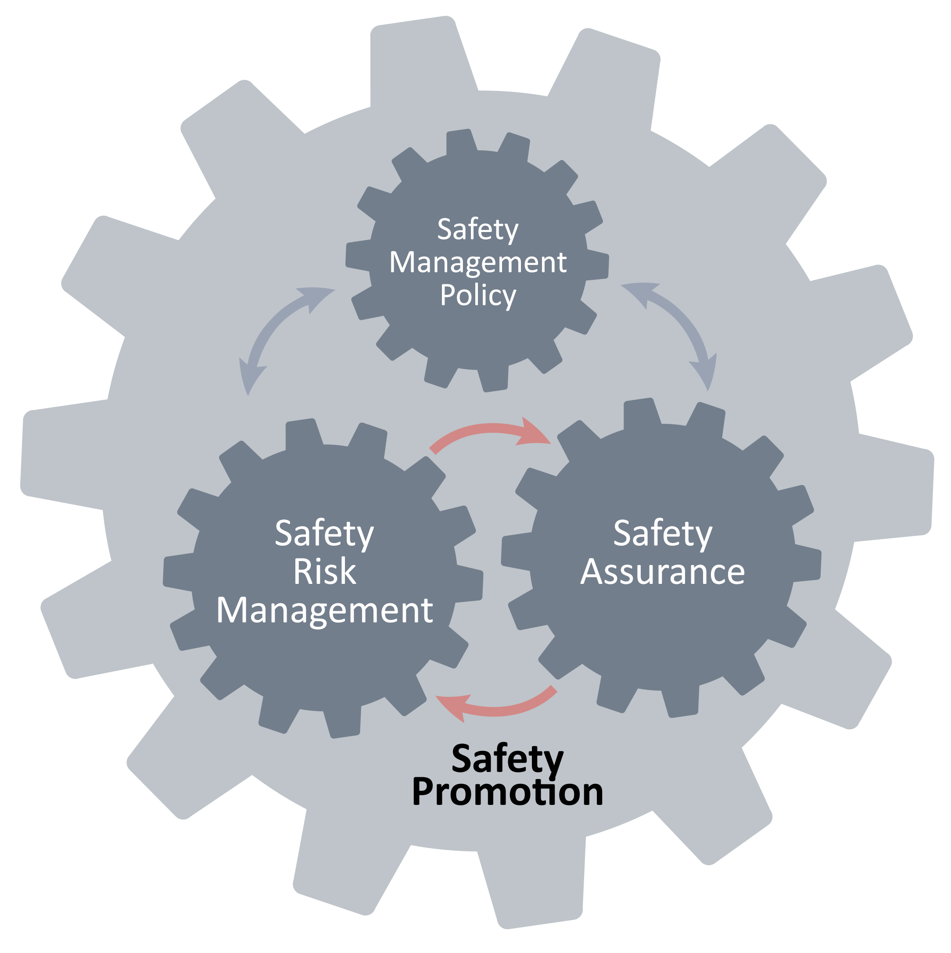

I. – Safety Management Policy
The Safety Management Policy is the written foundation of a public transportation agency’s safety management system. It formally and explicitly commits an agency to the development and implementation of the organizational structures and resources necessary to sustain the safety management processes and activities of an SMS. An effective Safety Management Policy establishes that a transit agency’s top executive is ultimately accountable for safety management.
SMS is formal and structured
SMS defines management commitment to meet established safety objectives and safety performance targets
The Safety Management Policy component encompasses an agency’s safety objectives and safety performance targets, and the necessary organizational structures to accomplish them. It establishes senior leadership and employee accountabilities and responsibilities for safety management throughout an agency. It also commits senior leadership to the oversight of an agency’s safety performance through meetings and regular reviews of activity outputs and discussions of resource allocation with key agency stakeholders.
The Safety Management Policy is implemented in practice though the Safety Management Policy Statement, which the Accountable Executive formally endorses.
Safety Management Policy Sub-Components
- Safety Management Policy Statement – This sub-component clearly frames the fundamentals upon which a transit agency will build and operate its SMS. It documents executive management’s commitment to the SMS, and places the management of safety at the same level as a transit agency’s topmost business processes. Appendix B provides an example of a Safety Management Policy Statement.
To be effective, a transit agency’s Safety Management Policy Statement addresses the following six crucial aspects:
- Must be signed by the highest executive in the agency (typically, the Accountable Executive (CEO/GM) or Board of Directors/oversight entity) to convey that SMS is important to the highest level of the organization;
- Includes a clear statement about providing resources for managing safety during service delivery because no activities, safety-oriented or otherwise, can operate without resources;
- Commits the agency to an employee safety reporting program to convey that receiving safety information from employees is critical to the operation and success of the SMS;
- Defines conditions under which exemptions from disciplinary actions would be applicable, thus encouraging the reporting of safety concerns by employees;
- Spells out unacceptable operational behaviors; and
- Is communicated, with visible and explicit support from executive management, throughout the transit agency.
Finally, the Safety Management Policy Statement documents management’s commitment to continuous safety improvement, as well as to the continuous improvement of the safety management system itself.
- Safety Accountabilities and Responsibilities – This sub-component defines the accountabilities and responsibilities for the performance of the SMS. It describes the relationships between the Accountable Executive and a transit agency’s governance structure.
Under the Safety Accountabilities and Responsibilities sub-component, an Accountable Executive is identified and accountabilities, responsibilities, and authorities are defined for the executive and senior managers. These accountabilities, responsibilities (and their delegation), and authorities ensure the effective and efficient operation of the SMS, and may vary from agency to agency based on the size and complexity of the agency.
It is critical to appoint a subject matter expert for the implementation and day-to-day operation of the SMS, as well as staff necessary to support the subject matter expert in the day-to-day operation of the SMS. The following sample responsibilities would most likely fall to this SMS manager:
- Directs collection and analysis of safety information;
- Manages hazard identification and safety risk evaluation activities;
- Monitors safety risk mitigations;
- Provides periodic reports on safety performance;
- Advises senior management on safety matters;
- Maintains safety management documentation; and
- Plans and organizes safety training.
While SMS responsibilities will not look the same at all transit agencies, the following are some anticipated, and minimum, sample responsibilities that fall on all line and technical management personnel who have responsibilities under SMS:
- Actively support and promote the SMS;
- Ensure that they and their staff comply with the SMS processes and procedures;
- Assist in ensuring that resources are available to achieve the outcomes of the SMS; and
- Continually monitor their area of SMS responsibility.
Each transit agency will determine the structure for accountabilities and responsibilities that will best support its SMS. However, the following principles apply to all:
- Ensure accountability for SMS performance is at the highest level of the organization;
- Implement SMS in a manner that meets transit agency safety performance objectives;
- Establish the meeting or committee structure necessary for the size of the agency to ensure that safety information moves up, down and across the agency; and
- Effectively communicate roles and responsibilities to all relevant individuals.
- Integration with Public Safety and Emergency Management – This sub-component ensures integration of programs that have input into, or output from, the SMS. Each transit agency will identify and describe the necessary coordination with both external organizations and internal departments for dealing with emergencies and abnormal operations, as well as the return to normal operations. This sub-component addresses the various internal and external programs that may affect safety management and includes an index of the plans and procedures that support the transit agency’s public safety and emergency management activities.
- SMS Documentation and Records – This sub-component includes the activities for the documentation of SMS implementation, the tools required for day-to-day SMS operation, and the management of new or revised safety requirements, regulatory or otherwise.
The extent and complexity of the SMS documentation will be commensurate to an agency’s size and complexity. SMS documentation and records must be readily available to those with accountabilities for SMS performance or responsibilities for SMS implementation and operation.
II – Safety Risk Management
SMS is proactive
- Safety Risk Management promotes the identification of hazards before they escalate into accidents or incidents.
- Safety Risk Management evaluates safety risk and establishes necessary mitigations.
The Safety Risk Management component is comprised of the processes, activities, and tools a transit agency needs to identify and analyze hazards and evaluate safety risks in operations and supporting activities. It allows a transit agency to carefully examine what could cause harm, and determine whether the agency has taken sufficient precautions to minimize the harm, or if further mitigations are necessary.
All transit agencies have implemented activities to identify safety concerns. Under an SMS, this practice will expand to ensure use of both proactive (i.e. employee safety reporting) and reactive (i.e. investigations) sources that are as comprehensive as necessary for the size and complexity of the agency.
Through ongoing Safety Risk Management activities, safety hazards and concerns in transit operations are identified, evaluated, and mitigations are put in place to manage their safety risk.
Safety Risk Management sub-components
- Hazard Identification and Analysis – As the first two steps in the Safety Risk Management process, hazard identification and analysis identify and address hazards before they escalate into incidents or accidents. They also provide a foundation for the risk evaluation and mitigation activities that follow.
Hazards are an inevitable part of transit operations. Only after a transit agency identifies hazards can it address them. Many transit agencies have some of the following hazard identification sources in place:
  - Employee safety reporting program
  - Observations of operations
  - Inspections
  - Internal safety investigations
  - Accident reports
  - Compliance programs
  - Committee reviews
  - Industry data
  - Governmental sources (FTA, NTSB, oversight agency)
  - Customer and public feedback or complaints
There are many sources for safety information and many ways to identify hazards, and the sources and methods used depend on the size and complexity of the organization. The data sources may vary, but there are key attributes of effective hazard identification:
- The more comprehensive the data sources, the more confident management can be that safety concerns are being identified;
- Training employees on proper identification and reporting of safety concerns increases the likelihood that hazards can be addressed;
- Focus on the collection of safety concerns while safety representatives work with operations and management personnel to identify the exact hazard(s); and
- Promote and support agency-wide safety concern reporting and hazard identification.
Each transit agency will establish its preferred methods for hazard analysis. As appropriate, subject matter experts from relevant departments should be involved in a transit agency’s hazard analysis.
- Safety Risk Evaluation and Mitigation – Following hazard identification, a transit agency implements activities and tools to evaluate safety risks associated with identified hazards, and subsequently develops mitigations to reduce safety risk exposure.
The term “safety risk” represents the likelihood that people could be harmed, or equipment could be damaged, by the potential consequences of a hazard and the extent of the harm or damage. Therefore, safety risk is expressed and measured by the predicted probability and severity of a hazard’s potential consequences.
Safety risk evaluation must consider existing mitigations when determining whether further measures are needed to mitigate the potential consequences of a hazard. Safety risk mitigations are actions taken to reduce the likelihood and/or severity of the potential consequences of a hazard.
Safety risk mitigation enables a transit agency to actively “manage” safety risk in a manner that is aligned with its safety performance targets, and consists of initial, ongoing, and revised mitigations.

III – Safety Assurance

Safety Assurance builds confidence and assures mitigation effectiveness
- Safety Assurance ensures that transit agencies implement appropriate and effective mitigations.
- Safety Assurance is a never-ending process that monitors the safety performance of an organization.
The Safety Assurance component ensures that mitigations are implemented, adhered to, appropriate, effective and sufficient in addressing the potential consequences of identified hazards. Mitigations developed under the Safety Risk Management process are “handed-off” to Safety Assurance analysts reviewing the data to determine if (1) the mitigations are effective, and (2) that no new risks have been introduced through implementation of the mitigations. Safety Assurance also ensures that the SMS is effective in meeting an agency’s safety objectives and safety performance targets. A transit agency assures its safety objectives are met through the collection and analysis of safety data, including the tracking of safety risk mitigations.
A transit agency implements its Safety Assurance process through the active monitoring of operations, safety reporting systems, routine workplace observations, inspections, audits, and other activities, designed to support safety oversight and performance monitoring. An effective employee safety reporting program is essential to the Safety Assurance function.
Safety Assurance also helps a transit agency evaluate whether an anticipated change may affect the safety of operations. If an anticipated change is determined to introduce safety risk, a transit agency would conduct Safety Risk Management activities to minimize the safety risk associated with the change.
Safety Assurance sub-components
- Safety Performance Monitoring and Measurement – SMS generates data and information that senior management needs in order to evaluate whether implemented safety risk mitigations are appropriate and effective, and how well an agency’s safety performance is in line with established safety objectives and safety performance targets. Safety performance monitoring does not focus on monitoring individuals, but rather monitoring the safety performance of a transit agency itself through routine monitoring of operations and maintenance activities.
Examples of safety performance monitoring activities include the following:
  - Monitor employee safety reporting program
  - Monitor service delivery activities (must include field observations)
  - Monitor operational and maintenance data
  - Conduct safety surveys
  - Conduct safety audits, studies, reviews, and inspections
  - Conduct safety investigations
  - Evaluate data and information from external agencies or peers
- Management of Change – Change may introduce new hazards and safety risk into transit operations. Therefore, agencies should establish the criteria that define when a change must be evaluated through the Safety Risk Management process. If a proposed or identified change meets or triggers those criteria, the agency uses Safety Risk Management to review existing mitigations to determine if they are sufficient or if new mitigations are necessary. It is important that a transit agency leverage its field monitoring activities (under the Safety Performance Monitoring and Measurement sub-component) to support the identification of changes in a system that may not be planned.
- Continuous Improvement – Evaluation of the SMS is necessary to ensure that it effectively and efficiently allows the agency to meet safety objectives and performance targets. Transit agencies should address any identified weaknesses in SMS organizational structures, processes, and resources in a timely manner, and also complete annual reviews of overall safety performance.
IV – Safety Promotion
Safety Promotion provides visibility of executive management’s commitment to safety, and fosters improved safety performance by increasing safety awareness through safety communication and training. Through communication of lessons learned and broader safety information, employees are made aware of safety priorities and safety concerns at both the organizational level and as they relate to their own duties and responsibilities.
The appropriate training for all staff, regardless of their level in the agency, provides visibility for, and knowledge of, the SMS. It ensures employees receive the training they need to do their job safely, and gives them shared ownership of the transit agency’s safety mission. This training commitment demonstrates management’s commitment to establishing an effective SMS.
Safety Promotion sub-components
- Safety Communication – A two-way feedback loop between frontline employees and management about safety information is crucial in establishing a positive safety culture. Effective safety communication makes personnel aware of safety priorities and initiatives and ensures that feedback is captured and acted upon as appropriate. Safety-related information must be actively and routinely communicated, and must focus on raising awareness of hazards and potential safety risks. Regular discussion of safety concerns promotes an environment that encourages employees to report concerns and demonstrates management commitment to both the employees and the agency’s safety performance objectives.
- Competencies and Training – Training of all employees with respect to their role and responsibilities as they relate to agency safety performance is perhaps the most critical driver for successful SMS implementation. It also shapes employee perception of executive management’s commitment to safety. Achieving appropriate levels of competency for each staff level enables the consistent application of their skills to help the transit agency achieve its safety performance objectives.
SMS promotes a strong culture of safety
- Safety Promotion encourages and teaches safety through effective communication and training.
- Safety Promotion ensures employees at all levels get the training they need to do their job safely.
At the frontline employee level, safety management training should provide for the development of safety reporting competencies, i.e. employees should receive formal training on the expected contents of employee safety reporting (what to report; what not to report) and the procedures established for reporting.
At the safety management level, formal training should develop safety data management competencies, i.e. how to analyze safety data, extract information from the safety data, and turn safety information into safety intelligence for senior management decision-making for the allocation of safety management resources.
SMS Implementation and Maturity
SMS implementation occurs over time and requires a shift in the management and perception of safety by individuals and the organization as a whole.
A transit agency builds SMS maturity through a series of steps that lead to confidence that safety risk is being identified, evaluated, and mitigated to an extent that is consistent with its safety objectives and safety performance targets. An agency’s SMS is mature when agency employees, from Accountable Executive to frontline operators, can unequivocally answer these five questions:
- What are our most serious safety concerns?
- How do we know this?
- What are we doing about it?
- Is what we are doing working?
- How do we know what we are doing is working?
The steps to SMS implementation maturity will vary among transit agencies, as constraints and possibilities in approaching safety management, its communication, and training will vary greatly from agency to agency. The FTA hopes that this SMS Framework, and subsequent training, guidance, and assistance, will help expedite SMS maturity within the industry.
While every transit agency is unique, the common goal from the Board of Directors to the Accountable Executive, middle management, supervisors, and frontline employees is to ensure that passengers reach their destination safely and employees return home each day.

SMS Implementation Phases
The Three Implementation Phases of SMS
- Phase 1 – Planning, Organization and Policy Development
- Phase 2 – Safety Risk Management
- Phase 3 – Safety Assurance

The FTA proposes three phases for SMS implementation. Each implementation phase is associated with a component of the FTA SMS Framework. There is no specific phase associated with Safety Promotion because safety management training and safety communication are ongoing activities that intertwine in all implementation phases and the life cycle of SMS.

Phase 1 – Planning, Organization and Policy Development
The objectives of Phase 1 are to (a) generate a blueprint of how to meet and integrate SMS requirements into a transit agency’s service delivery operations, (b) create an accountability framework for the development of SMS implementation activities, and (c) develop safety policy documents.
The SMS gap analysis is central to Phase 1. A gap analysis is an assessment of where the transit agency is today with respect to implementing SMS, as compared to a fully mature SMS. From the SMS gap analysis, a transit agency can determine the status of its safety management processes, including the organizational structures and resources necessary to support them. From this baseline, a transit agency can plan to develop or strengthen existing safety management processes.
The output of Phase 1 is the SMS implementation plan and completion of safety policy development.
Phase 1 Completion
At the completion of Phase 1, a transit agency should have finished the following tasks in a manner that meets the expectations set forth in relevant requirements and guidance material:
- Appoint the person and/or assemble the team responsible for the development of the SMS implementation plan;
- Conduct an SMS implementation gap analysis by reference to the components and sub-components of the FTA SMS Framework;
- Develop an SMS implementation plan that describes the development of organizational structures and deployment of resources that are required for managing safety under SMS. The SMS implementation plan must detail the tasks, the task owners, and due dates;
- As part of the SMS implementation plan:
- Identify the Accountable Executive and the safety management accountabilities of managers;
- Develop the Safety Management Policy Statement draft;
- Identify the departments involved with the integration of emergency plans, procedures, and/or protocols that direct both internal emergency response to transit related events and external emergency response with local emergency services for community-wide emergency activities;
- Develop the blueprint of essential activities and tools of the Safety Risk Management process;
- Develop the blueprint of essential activities and tools of the Safety Assurance process;
- Identify safety management training needs based on audience groups; and
- Develop the infrastructure for safety management communication.

Phase 2 – Safety Risk Management
The objectives of Phase 2 are to (a) establish and implement Safety Risk Management activities and tools so a transit agency can identify and analyze hazards and evaluate safety risks, and (b) correct potential shortcomings, from an SMS viewpoint, in activities and tools that an agency already has in place. Organizationally, this is accomplished when safety risk management responsibility moves beyond just the safety department and into each operational division of the agency.
Most transit agencies have Safety Risk Management activities, though at different levels of implementation maturity and with different degrees of effectiveness. These activities and tools may include information analysis from accident reports, incident investigations, and employee reports.
Phase 2 strives to strengthen existing activities and tools and to develop those that do not yet exist. Toward the end of Phase 2, a transit agency will be ready to perform integrated safety analyses based on information obtained through different methods of safety data collection.
Phase 2 Completion
At the completion of Phase 2, a transit agency should have finished the following tasks in a manner that meets the expectations set forth in relevant requirements and guidance material:
- Hazard identification and analysis
  - Establish criteria and guidance for the activities and tools for hazard identification and analysis; and
  - Establish an employee safety reporting program.
    - Clearly identify the non-punitive aspects of the employee safety reporting program.
    - Clearly identify behaviors that are exempt from discipline.
- Safety risk evaluation and mitigation
  - Develop and adopt safety risk matrices for probability and severity, and evaluate safety risks associated with service delivery operations; and
  - Establish criteria for the elevation of safety risks to executive management, as necessary.
- Develop hazard identification, analysis, safety risk evaluation, and mitigation documentation;
- Develop and deliver training for hazard identification, analysis, safety risk evaluation, and mitigation to relevant personnel, and include the training material in relevant transit agency documentation;
- Communicate the start of the employee safety reporting program; and
- Communicate the completion of the tasks above to relevant personnel throughout a transit agency.

Phase 3 – Safety Assurance
The objectives of Phase 3 are to (a) implement essential Safety Assurance activities and tools that allow a transit agency to monitor safety performance during service delivery operations, (b) manage operational change, and (c) provide for continuous improvement of the SMS.
Phase 3 strives to strengthen existing Safety Assurance activities and to develop those that do not yet exist. At the end of Phase 3, a transit agency will be ready to monitor safety risk controls and engage in continuous corrective action to maintain their effectiveness over time and under changing operational demands.
Phase 3 Completion
At the completion of Phase 3, a transit agency should have finished the following tasks in a manner that meets the expectations set forth in relevant requirements and guidance material:
- Safety performance monitoring and measurement
  - Develop safety performance monitoring and measurement activities; and
  - Establish safety performance indicators and safety performance targets.
- Management of change
  - Define trigger thresholds for engaging in change management activities (i.e. hazard identification, analysis, and safety risk evaluation); and
  - Ensure no service delivery operations will be initiated in the changed environment until an initial evaluation has been conducted.
- Continuous improvement
  - Develop criteria for SMS continuous improvement;
  - Establish SMS assessments; and
  - Define internal SMS assessment activities.
  - Identify safety assurance and oversight activities carried out by external agencies.
- Document all safety performance and monitoring, management of change, and continuous improvement activities;
- Develop and deliver training on safety performance and monitoring, management of change and continuous improvement, and include the training material in relevant documentation; and
- Communicate the completion of all the above tasks to relevant personnel.

(Intentionally left blank)

Chapter III – SAFETY PERFORMANCE MANAGEMENT

What is performance management?
MAP-21 transformed the Federal transit program by establishing new requirements for performance management for safety and transit asset management. Through the establishment of goals, measures, targets and plans, performance management refocuses attention on accountability and transparency and improves project decision-making through performance-based planning and programming. The performance management requirements are intended to facilitate more effective investment of Federal transportation funds by refocusing attention on national, regional, and local transportation goals, increasing the accountability and transparency of the Federal transit and Federal-aid highway programs, and improving project decision-making through performance-based planning and programming.
FHWA and FTA are undertaking a number of separate, but related rulemakings, to implement the performance management framework and establish national performance measures. FTA must establish performance measures and performance criteria for transit asset management and safety, respectively. 49 U.S.C. 5326(c), 49 U.S.C. 5329(b)(2). On September 30, 2015, FTA published a Transit Asset Management (TAM) NPRM which included proposed performance measures for public transportation capital assets. At this time, FTA is proposing safety performance criteria (measures) through this Plan instead of through a rulemaking; however, the requirement that transit providers set targets based on the criteria in this Plan will be in the rule to establish requirements for public transportation agency safety plans.
Safety performance management is a critical tool that should allow transit providers and FTA to identify safety concerns and monitor progress in safety improvement. FTA’s safety mission, vision and focus areas provide strategic direction for safety performance management. The vision and mission are achieved through focusing the national effort to improve safety performance in key areas. Based on the vision, mission, and focus areas, FTA will set performance criteria to measure progress towards improving safety performance and help build a common understanding of the state of safety performance, infrastructure security, and resilience efforts.

VISION  To assure safe public transportation nationwide through improved risk-based safety management. | MISSION  To strive for the highest practical level of safety for all modes of public transportation by providing a risk-based safety management structure to lead and support the public transit industry.
The realization of FTA’s safety vision depends on building the strategic partnership for safety from the top down, and addressing day-to-day safety concerns from the bottom up, across each transit agency and throughout the transit industry. FTA intends to guide, support, and monitor the implementation of the SMS framework across the public transportation industry. As FTA works to implement 49 U.S.C. Section 5329 requirements, publishes notices of proposed rulemaking, develops a new safety data analysis and reporting regime, and implements new safety programs, we will build mechanisms to identify and address specific safety challenges. Both FTA and public transportation providers will apply the principles and methods of SMS to drive safety performance and subsequently achieve the safety focus areas below.
What are the Focus Areas?

FOCUS AREA: IMPROVE PUBLIC TRANSPORTATION SAFETY PERFORMANCE
Public transportation is an integral part of local and regional communities, providing access to all facets of life activities. The increase in demand for public transportation, combined with lack of funding for maintenance and renewal of assets, has led to system safety and preservation issues throughout the transit industry. Managing safety performance will help public transportation agencies make critical decisions about investments in safety, reconstruction, or rehabilitation of existing assets in order to achieve and maintain a state of good repair.

In coordination with public transportation providers, FTA intends to identify hazards and risks through safety risk management, and work to improve safety performance by helping identify means to mitigate those risks, while striving to meet the needs of customers, employees and the public. FTA will use safety oversight and safety assurance techniques to ensure that safety risk mitigations put in place are sufficient and help improve overall safety performance. As FTA engages in a national discussion about safety challenges, we will highlight issues that are trending nationally, and ask local transit entities to evaluate and consider whether these nationally-identified problem areas are also local issues of concern. We encourage states, MPOs, and transit agencies to review their own safety performance management, and build their own SMS's in order to more effectively conduct safety risk management and safety assurance on a local level.
FOCUS AREA: IMPROVE SAFE TRANSIT ACCESS AND TRANSIT FACILITY SAFETY
Transit-accessible communities promote a general sense of wellness and vitality, extending the walkability of neighborhoods and improving quality of life. It is these attributes that, in part, have created an increased demand for public transportation across the country and among all age groups and ethnicities. Therefore, FTA encourages public transportation agencies to incorporate into their local safety plans performance measures that foster safe access to and safe operation of their systems. Through coordination at the local and regional level, public transportation agencies can improve the safety of, and accessibility to, public transportation facilities and equipment, whether via sidewalks, crosswalks, bike paths, escalators or elevators.
Transit customers often access transit systems by walking or biking, as well as by driving. The safety of pedestrians and bicyclists is an important consideration as public transportation providers plan projects and operate service in their communities. FTA is working with agencies to foster a safer operating environment through the development of new programs, rules, and initiatives to assist the industry as it improves its overall safety. These activities will help to ensure the safe access and travel of all public transportation riders, employees, and the general public.
What are safety performance criteria?
FTA’s safety performance criteria are categories of measures that focus on the reduction of safety events, and fatalities and injuries of people accessing and riding public transportation (patrons are within transit facilities, but not on-board vehicles; customers are on-board transit vehicles), the employees who operate and maintain the systems, and pedestrians, bicyclists, and drivers of other vehicles affected by the safe operation of public transportation vehicles (public). At the national level, FTA is establishing safety performance criteria to help monitor the transit industry’s safety performance. In order to capture the broad and varied nature of public transportation, in this first National Safety Plan, FTA is proposing criteria that can be applied to all modes of public transportation and are based on data currently collected in the National Transit Database (NTD).
Pursuant to 49 U.S.C. 5329(d), a Public Transportation Agency Safety Plan must include safety performance targets based on the safety performance criteria proposed in this Plan. The categories of measures (fatalities, injuries, safety events and system reliability) selected by FTA, while broad in order to be relevant to all public transportation modes, are intended to provide a “state of the industry” high-level measure, and also help focus individual agencies on the development of specific and measurable targets relevant to their operations. These should also inform agencies as they identify actions they each would take to improve their own safety outcomes. Unlinked passenger trips are used here in order to ensure that exposure to hazards is captured during the development of agency safety performance targets, and during safety performance monitoring. Rate per trip or per mile is also intended to ensure that the scale of human exposure to potential safety hazards is captured.

SAFETY PERFORMANCE CRITERION: FATALITIES (total number of reportable fatalities and rate per total unlinked passenger trips by mode)
(customer, employee, and public)
- Paratransit – measured relative to total unlinked passenger trips
- Bus – measured relative to total unlinked passenger trips
- Rail – measured relative to total unlinked passenger trips
- Other modes – measured relative to total unlinked passenger trips

SAFETY PERFORMANCE CRITERION: INJURIES (total number of reportable injuries and rate per total unlinked passenger trips by mode)
(customer, employee and public)
- Paratransit – measured relative to total unlinked passenger trips
- Bus – measured relative to total unlinked passenger trips
- Rail – measured relative to total unlinked passenger trips
- Other modes – measured relative to total unlinked passenger trips

SAFETY PERFORMANCE CRITERION: SAFETY EVENTS (total number of reportable events and rate per total vehicle miles, by mode)
- Derailments
- Collisions
- Fires
- Evacuations for life safety

SAFETY PERFORMANCE CRITERION: SYSTEM RELIABILITY (mean distance between failures by mode)

- Total vehicle miles operated divided by total failures for each mode of service operated, based on the NTD definitions (FTA 2014).
- Major Mechanical System Failures: Major mechanical system failures prevent a vehicle from completing or starting a scheduled revenue trip because actual movement is limited or because of safety concerns. Examples of major bus failures include breakdowns of brakes, doors, engine cooling systems, steering, axles, and suspension.
- Other Mechanical System Failures: Other mechanical system failures prevent a vehicle from completing or starting a scheduled revenue trip even though the vehicle is physically able to continue in revenue service without creating a safety concern. Common examples include breakdowns of fare boxes, wheelchair lifts, heating, ventilation, and air conditioning (HVAC) systems.
FTA anticipates the specificity of national safety performance criteria will grow commensurately with the level of detail in the safety data and information that is collected, and through continuous national-level safety risk evaluation.

Why Did FTA Choose These Measures?

FTA selected the category of fatalities because reducing the number of fatalities is a top priority for all modes of transportation. Each fatality is something that, as an industry, we want to understand and try to prevent further occurrences. Measuring the rate of fatalities over all the passenger trips provided, by mode, gives us a high-level measure (rate of fatalities by mode) from which future performance can be assessed.
The same is true of the category of injuries. Many transit agencies have never had a fatality, and continued safe operation is exactly what is desired. However, injuries occur much more frequently, and are due to a wide variety of circumstances. Analyzing the factors that relate to injuries is a significant step in developing actions to prevent them. Again, measuring the rate of injuries by mode, over all the passenger trips provided gives us a proxy for the level of exposure to the population. This also gives us a high-level measure (rate of injuries by mode) from which future performance can be assessed.
The category of safety events is the collection of reported events that occur during the operation of public transportation and the performance of regular supervisory or maintenance activities, and is measured relative to total vehicle miles. FTA chose this high-level measure because exposure to events depends on the amount of time, speed, and number of vehicles transit agencies operate. The number of total vehicle miles represents the extent to which vehicles are in operation, whether with or without customers. The opportunity for a safety event is present whenever vehicles are being operated. This gives us a high-level measure from which future performance can be compared.
Finally, the category of system reliability is intended to measure the relationship between transit asset management practices and the safety of a public transportation system. FTA selected the system reliability measure to help measure the overall condition of the transit industry’s operating systems. The rate of vehicle failures in service, defined as mean distance between failures, is measured as revenue miles operated, divided by the number of failures. This is a measure of how well a fleet of transit vehicles (and the infrastructure on which it operates) is maintained and operated. FTA recognizes the diversity of the transit industry, and that agencies have varied equipment types, with varied rates of performance, so this measure allows agencies to develop safety performance targets that are specific to their own fleet type, age, operating characteristics, and mode of operation.
The selection of each measure was based on data that is already collected through the NTD and the SSO program and which is discussed in greater detail below. FTA recognizes that each transit agency has its own operating policies that impact how performance is reported to the NTD. However, bringing greater attention to safety and reliability metrics will encourage more robust, consistent data reporting in the future.

How are the safety performance criteria used to improve safety performance?
Establishing baseline measures is the first step toward creating meaningful performance targets. The public transportation industry already has parameters for measuring some aspects of safety performance which are reported to the NTD. However, these measures need clear definitions to ensure consistency in data reporting, and better baselines against which to make future comparisons. To address these inconsistencies, FTA will develop performance measures for future editions of the National Safety Plan that address broad concerns as well as those that are mode-specific. Transit agencies would have the opportunity to select among them those that address their particular concerns for safety improvement.
Table 3-1 Data and Information from Safety and Risk Monitoring in the Transit Industry
Existing safety performance measures (under NTD)
- Casualties
- Fatalities (customers, employees, and the public)
- Injuries (customers, employees, and the public)
- Property damage
- Reportable events (Accidents)
- Train derailments (mainline, yard, side tracks)
- Collisions (vehicle-to-vehicle, vehicle-to-person, vehicle-to-object)
- Collisions at grade-crossings
- Fires
- Evacuations for life safety reasons
Results from reportable event (accident) investigations
- Probable cause
- Contributing factors
- Corrective actions
Audit results
- Findings
- Corrective actions
Hazard management and risk monitoring information
- Safety reporting from all levels of the organization
- Violations of O&M rules
- Job-based certification and awareness training
- All-hazards preparedness analyses
- O&M performance, including state of good repair (SGR) and TAM
- Monitoring of hazard logs
- Crime trends, such as trespassing, perimeter breaches, and fare evasion
- Fitness for duty, including drug/alcohol program results and hours of service
- Liability losses
- Customer complaint information
- Changes to management, operations, or maintenance
- Studies of hazardous materials, spills, and environmental concerns
- Ad hoc studies of hazards and vulnerabilities
For every performance measure selected, FTA, States, and public transportation agencies would develop baselines and targets against which to measure and compare performance. Establishing baselines for performance measures provides grounded metrics as the bases for further and future comparison. The baseline for any safety performance parameter should include at least three years of data to establish an initial time-weighted average (metric) for the measure.
Performance baselines may be established for individual transit agencies, for transit agency modes, and/or for the public transportation industry as a whole. After baseline metrics are stable for individual transit agencies or modes, the agencies or modes can select targets (metrics) for safety performance improvements. Performance should be measured at least annually by comparing actual performance metrics with targets and original baselines. As performance improves, baselines and targets may be updated. As targets are achieved, transit agencies may select different safety parameters and targets for improvement.
Transit safety performance can be measured using a number of parameters, including accidents, fatalities, injuries, and property damage associated with transit agencies’ provision of service. Individual safety performance measures are often called “indicators.” Those that can predict safety accidents are referred to as “leading” indicators. Those that can only assess outcomes are referred to as “lagging” indicators. Table 3-2 describes lagging and leading indicators in greater detail.

Table 3-2. Lagging and Leading Indicators
Lagging indicators characteristically:
- Identify trends in past safety performance
- Assess outcomes and occurrences
- Have a long history of use
- Are an accepted standard
- Are easy to calculate
Leading indicators are safety culture metrics that are associated with, and precede, an accident. They can:
- Reveal areas of weakness in advance of accidents
- Be associated with proactive actions to identify hazards
- Aid risk assessment and management
All of the established safety performance measures for transit (see Table 5-1) are examples of lagging indicators. An example of a leading indicator may be the amount of lead time for refresher training. That is, long delays in completion of (safety) refresher training may precede and “predict” certain safety accidents. If the correlation is strong enough, an organization may allocate additional resources to assure that refresher training is completed on schedule.
Performance data should be aggregated for a minimum of two years to be able to begin to establish a trend. If more robust data exists – and is reliable, meaning the source data is clean of manipulation or post-processing following its capture in the system of record – then that data should be used. Targets should be based on relevant factors that impact performance and can be effectively and consistently measured. Once baseline data is established, and a reasonable range of performance can be defined, targets may be set. Target setting should be a data-driven process. Targets should be based on relevant factors that impact performance and can be effectively and consistently measured.
The safety performance criteria presented above in this Plan, and safety trends below, allow transit providers to benchmark their performance relative to these high-level industry measures. Due to the differences between agencies and operating environments noted earlier, comparing agencies to one another is not FTA’s intent, but rather to encourage agencies to improve their performance, which will contribute to the industry’s performance.
This is also the starting point from which FTA expects to advance through the development and implementation of a new strategic data management plan which will support the standardization of data and information collection and analysis. Standardized analyses and reporting will enable FTA to apply meta-analyses to transit safety performance results for better national-level monitoring of transit safety performance. Along with continued collaboration with States and the public transportation industry, this national-level monitoring will facilitate FTA’s identification of opportunities to assist agencies in improving transit safety through technical assistance, research, and development of resource materials that address emerging safety issues.
FTA expects that each agency, regardless of size, will evaluate its own operating environment and safety concerns to determine its safety risks, link specific safety objectives to agency actions, develop measures for identified actions, and set performance targets based on the measures. After FTA issues a final rule for Public Transportation Agency Safety Plans, each transit agency will be required to reevaluate its safety performance measures annually when reviewing and updating its agency safety plan, and determine how these measures should be refined, sub-measures developed, and performance targets selected.

What Safety Data Does FTA Currently Collect, and What Does it Say?
FTA currently maintains two sources for safety data reporting: the NTD, to which transit agencies report data as a condition for funding for public transportation agencies, and the State Safety Oversight (SSO) program, as required by 49 CFR Part 659, for rail transit modes that do not fall under Federal Railroad Administration jurisdiction. FTA utilizes these data sets to provide indicators of safety performance in outcome measures such as safety events, fatalities and injuries, as well as to provide trends in areas for which FTA believes additional focus may be warranted.
Current reporting of safety-related data and information in the transit industry is complex. Almost all transit agencies and modes report safety-related data to NTD. Rail transit agencies also annually submit safety-related data and information to FTA’s SSO program through their SSOA. Small/rural transit agencies, mostly bus and paratransit modes, usually report NTD data as a grant sub-recipient through their SDOT. Transit agencies with urban bus mode operations report safety-related data directly to NTD.
SAFETY EVENTS, FATALITIES AND INJURIES, 2009 – 2013
During the period 2009 – 2013, bus transit accounted for a majority of the industry’s passenger trips, as well as the majority of safety events, fatalities and injuries. While rail transit accounted for 42% of all passenger trips, only 17% of safety events were attributable to rail transit. However, this 17% share of safety events resulted in 35% of all transit fatalities, but only seven percent of injuries reported. In other words, rail-related safety events have occurred less frequently, but the average rail-related safety event had more catastrophic outcomes than the average bus-related safety event during the time period.
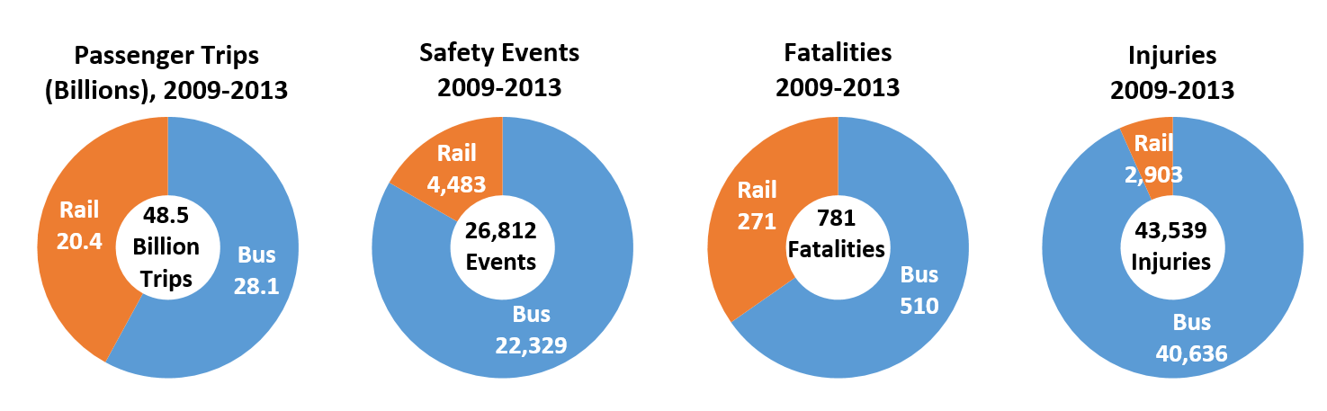
Sources: SSO program (rail safety data), NTD (service and bus safety data)

The following table presents transit safety metrics per 100 million passenger trips for the last five years. As an industry, safety events, fatalities and injuries show an upward trend, and through safety performance monitoring, FTA hopes that agencies can investigate the reasons for this trend, and mitigate identified causal safety risks. However, by itself, rail transit shows downward trends in fatalities and injuries.

Transit Safety Events, Fatalities and Injuries
per 100 Million Passenger Trips 2009-2013
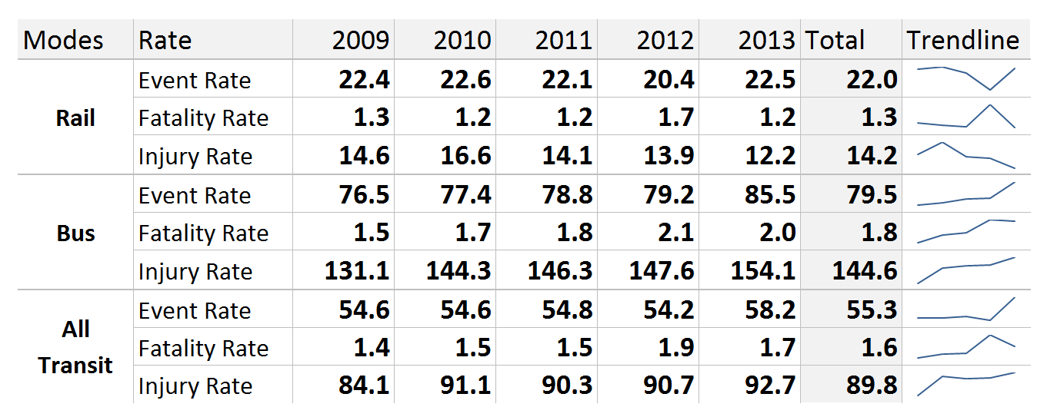
Sources: SSO program (rail safety data), NTD (service and bus safety data)

NOTE: Data includes safety events (reportable derailments, collisions, fires, and evacuations), fatalities (not including suicides or trespassers), and injuries (not including assaults or injuries due to crimes).
FATALITIES
Over the five-year period from 2009-2013, transit agencies reported a total of 781 fatalities. 510 of these occurred in bus and other non-rail operating environments (65%), and 271 occurred in rail operating environments (35%).
When these data are normalized by looking at the number of fatalities divided by the number of passenger trips provided, the fatality rates over the last five years average 1.6 fatalities per 100 million passengers transported. This rate has been relatively steady, but has been trending slightly upward over the reporting period.
Heavy Rail and Light Rail Fatalities: 2009 - 2013
Fatality rates vary across rail modes due in large part to distinct operating environments and the inherent safety risk exposure associated with each. The charts below present heavy rail and light rail fatalities by person type, including passengers (customers onboard a transit vehicle), patrons (customers not onboard a vehicle), public (non-customers), and transit system employees, including right of way workers. It should be noted that heavy rail and light rail operations accounted for 266 of the 271 rail-related fatalities. An additional five fatalities occurred on automated guideway systems.
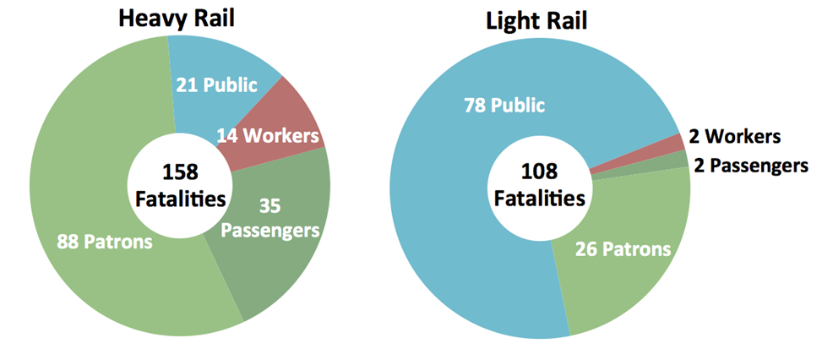
Source: SSO Program
Right of Way Worker Fatalities
Fatality data reflect the exposure characteristics of particular types of operations (e.g., whether or not grade crossings exist, whether stations are enclosed, and how many customers are served) and risk. For example, heavy rail transit has experienced several right-of-way (ROW) worker fatalities in recent years. The chart below presents ROW fatalities for all rail modes over the last 20 years. Vehicle revenue miles have increased approximately 56% over the past 20 years, increasing exposure for ROW workers.
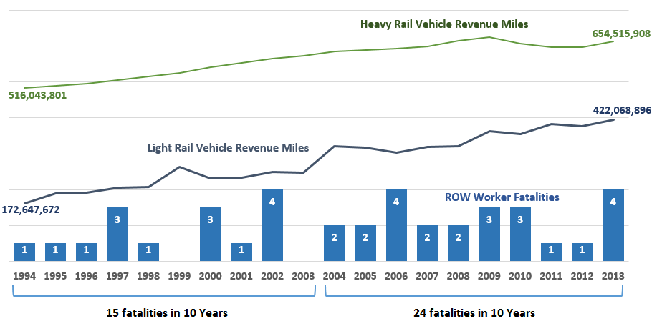
Source: SSO Program
Rail Grade Crossing Collisions
Light rail operating environments vary greatly from heavy rail systems. Light rail service utilizes rail grade crossings and even street-running alignments, increasing the exposure to vehicular and pedestrian traffic. Event data indicate a growing number of rail grade crossing events caused by pedestrians, as opposed to motor vehicles, underscoring the importance of ensuring safe transit access.

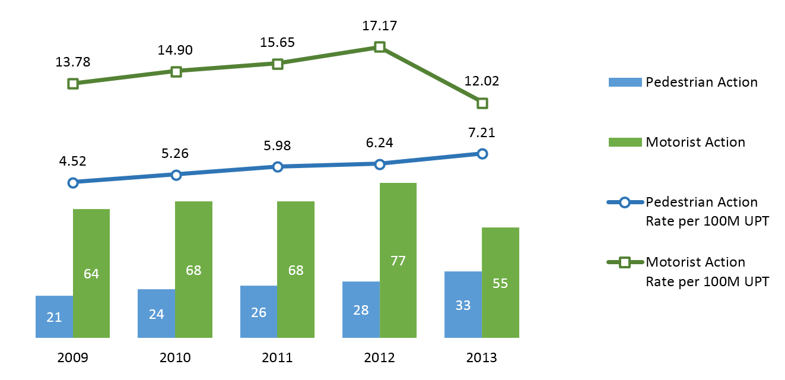
Sources: SSO program (rail safety data), NTD (service and bus safety data)

Bus and Paratransit Safety Events
Bus modes accounted for 28.1 billion trips between 2009 and 2013. This is 58% of the 48.5 total public transportation trips during the five-year period. Urban fixed-route bus modes represent 95% of these 28.1 billion trips. Demand response service and vanpools represent the remaining 5%. Data reveal that the safety performance of fixed-route bus modes is significantly better than demand response modes.
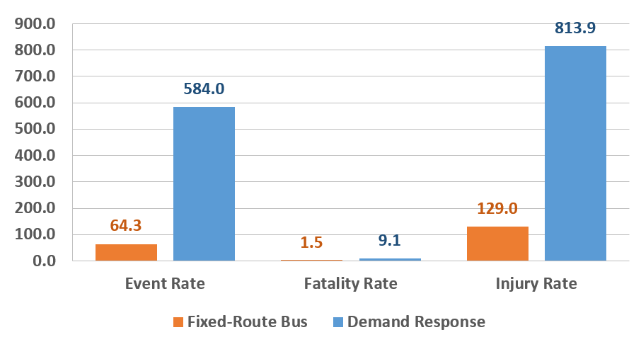
Source: NTD
SYSTEM RELIABILITY
The system reliability measure is dependent on a number of factors that affect transit agencies at a very local level, as mentioned above. In addition, it is known that agencies do not use the same definitions for this measure, even within the same mode of operation. Showing aggregated data would not provide a meaningful picture of reliability for the industry. As a result, FTA determined that it would not show aggregated data for this measure at this time, but in future revisions we hope to have sufficient data to add this information into the National Safety Plan.

What is the Relationship Between the National Safety Plan and Public Transportation Agency Safety Plans?
Section 5329(d) requires agencies to establish annual agency safety plans one year after the effective date of the agency safety plan final rule. One element of the agency safety plan is establishment of safety performance targets based on the safety performance criteria and state of good repair standards that are included in this Plan. Each public transportation agency should establish sub-measures and related safety performance targets in their Public Transportation Agency Safety Plans that are appropriate to the agency’s size and complexity. Transit agencies will use these safety performance measures and targets to inform evaluation of the effectiveness of their SMS. These measures should evolve in subsequent years based on information learned through the Safety Risk Management and Safety Risk Assurance processes, and should help inform these activities. Public transportation providers should be able to explain what happened as a result of actions taken during the performance measurement period that affected the safety outcomes. For example, what mitigations were put in place that appear to have led to increased agency safety?
In future versions of this Plan, FTA intends to report examples of safety actions and risk mitigations that have significantly improved outcomes. Likewise, FTA may identify safety hazards through analysis of data and oversight activities. Hazards that warrant increased review and analysis may be explored by the Transit Advisory Committee for Safety (TRACS), or by FTA, through a risk-based evaluation and decision-making process, leading to Safety Advisories, Safety Directives or other means of communication to help agencies improve their outcomes.

What is the Relationship Between Safety Performance and Transit Asset Management?

The safety and performance of a public transportation system depend, in part, on the condition of its assets. Factors such as people moving to urban areas, increasing reliance on public transportation, and aging transit assets put increased pressure on public transportation systems. This includes assessing safety risks related to or associated with the condition of agency assets. When transit systems are not in a state of good repair, the consequences may include increased safety risks, decreased system reliability, higher maintenance costs, and overall lower system performance.

In passing MAP-21, Congress recognized the critical relationship between safety and transit asset management. We note, in particular, the congressional direction that the National Public Transportation Safety Plan include the definition of state of good repair set in the rulemaking for asset management (49 U.S.C. § 5329(b)(2)(B)). In the rulemaking for transit asset management, FTA proposed a definition of state of good repair as the condition in which a capital asset is able to operate at a full level of performance.
Also, pursuant to the transit asset management requirements at 49 U.S.C. § 5326, FTA is proposing in the TAM rule making that all transit agencies do the following:
- Take inventory and assess the condition of their facilities, equipment, rolling stock, and infrastructure
- Develop a TAM Plan
- Report the condition of its capital assets, and any changes to the condition of the assets since its last report to the NTD, and
- List in their TAM Plan analytical processes or decision support tools that enable the transit agency to estimate its needs for investment in its capital assets, and prioritize its investments
Optimally, a transit agency’s asset management planning process will work hand-in-hand with the agency’s SMS for the mutual benefit of both, all under the leadership of the Accountable Executive. The following are three specific elements of the connection between safety and transit asset management:
- A condition assessment should direct and inform a transit agency’s SMS
The result of a condition assessment required under the National Transit Asset Management System may oblige the agency to perform risk assessment and quality assurance--in accordance with the second and third pillars of SMS--for facilities, equipment, rolling stock, and infrastructure in poor condition. Although an asset that is in poor condition might not pose any specific safety risk to the transit system, that asset still might be prioritized for repair, rehabilitation, or replacement if the asset is negatively affecting system performance, reliability, or quality of service. Even for an asset that is in optimal condition, a transit agency may have reason to perform a risk assessment in light of its operating environment or other agency objectives (for example, resiliency for assets in flood zones).
- A transit agency’s SMS will inform its TAM Plan and investment prioritization
The results of safety assurance and safety risk management under a transit agency’s SMS will provide valuable input to the agency’s TAM Plan, and, in some instances, motivate the agency to revise its investment priorities accordingly. Ultimately, a transit agency makes its own decisions about trade-offs and investment priorities, based on the analytical processes, decision support tool and policies under its TAM Plan, and the agency’s written policy for safety—the first pillar of an effective SMS—but the constant, deliberate feedback between the TAM Plan and the SMS will bring greater accountability and transparency to the agency’s decision-making on the annual allocation of its financial resources. Under the proposed TAM rule, a transit agency will make periodic reports on the condition of its transit system and any changes to that system, and will certify its compliance with the requirements for asset management.
- An agency’s Accountable Executive should have a decision-making role in the agency’s TAM Plan and investment prioritization
The Accountable Executive who is ultimately responsible for risk management and safety assurance under a transit agency’s SMS should be the same person who is responsible for approving the agency’s capital plan and who makes decisions about investment prioritization. At minimum, however, the Accountable Executive should have a focal role in the transit agency’s decision-making about the trade-offs amongst reinvestment in existing facilities, equipment, rolling stock, and infrastructure, versus investment in any new capital assets for purposes of improved performance of an expansion of service. Logically, the Accountable Executive for a transit agency’s SMS would be either the General Manager or a Chief Safety Officer who reports directly to that General Manager. Across the industry, however, there are a variety of organizational structures for transit agencies, and in many agencies, the decisional authority for capital and operating expenditures lies with a Board of Directors. Whatever the structure of an organization, the Accountable Executive should engage with other agency executives in a candid, continuous dialogue about the connection between safety and transit asset management.
Positive changes in safety performance across public transportation will depend largely on a common understanding between transit asset management and safety, dedicated implementation of both a TAM Plan and Public Transportation Agency Safety Plan, and a targeted safety oversight and monitoring program. The performance criteria, measures, and targets for both safety and transit asset management will enable transit agencies and FTA to quantify our progress in enhancing safety and improving the condition of our facilities, equipment, rolling stock, and infrastructure through continuous performance management.
How will Safety Performance Influence Metropolitan, Statewide, and Rural Planning?
The safety performance targets set by transit providers, along with other performance targets set pursuant to other statutes, are an essential component of the planning process. The planning provisions at 49 U.S.C. 5303 and 5304 require States and MPOs to establish performance targets for transit that are based on the national measures for state of good repair and safety established by FTA and to coordinate the selection of those performance targets, to the maximum extent practicable, with performance targets set by transit providers to ensure consistency. 5303(h)(2)(B)(ii), 5304(d)(2)(B)(ii).
Furthermore, the Long Range Statewide Transportation Plan should and the Metropolitan Transportation Plan shall include: (1) a description of the performance measures and targets; and (2) a report evaluating the condition of the transit system(s) with respect to the State and MPO performance measures and targets, including the progress achieved in meeting performance targets compared with system performance recorded in previous years. 49 U.S.C. 5303(i)(2)(B) and (C), 5304(f)(7). Transportation improvement programs (TIPs) and statewide transportation improvement programs (STIPs) must include, to the maximum extent practicable, a discussion of the anticipated effects of the TIP/STIP toward achieving the performance targets in the Statewide and Metropolitan Transportation Plans by linking investment priorities to those performance targets. 49 U.S.C. 5303(j)(2)(D), 5304(g)(4).
The integrated planning process mandated by MAP-21 should result in States and MPOs being able to identify investment and management strategies to improve or preserve the condition of transit capital assets in order to achieve and maintain a state of good repair. FTA and FHWA jointly issued an NPRM that proposed new requirements for Metropolitan, Statewide and Non-metropolitan Planning. Soon, a final rule will be published to guide the new performance-based approach to planning.
Transit providers that are subject to the requirements for transit agency safety plans would be accountable for setting annual safety performance targets based on the safety measures established by FTA in this Plan. The process of setting performance targets would require each transit provider to think quantitatively about its own safety needs and analyze what resources it could leverage to address those needs. How a transit provider sets its performance targets would be an entirely local process and decision. However, FTA would strongly encourage transit providers, States, and MPOs to set meaningful progressive targets, based on creative and strategic leveraging of all available financial resources. Although the law does not provide FTA with the authority to reward transit providers for meeting a performance target, or impose penalties for missing an S performance target, FTA believes that the process of setting targets and measuring progress reflects the increased expectations for improving transit safety.

(Intentionally left blank)

Chapter IV - Managing Risk and Assuring Safe Performance in Public Transportation

FTA will apply the principles and methods of SMS to drive activities that improve the safety performance of public transportation. FTA activities will guide, support, and monitor the implementation of the SMS framework across the transit industry. Using a risk-based oversight approach, FTA will initially focus on data collection and ongoing communication to support the analysis and identification of nationwide safety trends.
FTA will rely on several different tools to communicate actions to improve safety performance within the public transportation industry including, for example, rules, safety advisories, safety directives, and establishment of safety performance standards.
FTA SAFETY ADVISORIES
FTA has issued several Safety Advisories to the public transportation industry. An advisory is a notice from FTA to the transit industry that recommends a particular action to mitigate an existing or potential hazard or risk. While compliance is not mandatory, FTA strongly encourages transit agencies to take the actions recommended in an advisory. FTA has issued the following advisories:
Audit All Rail Fixed Guideway Public Transportation Systems (RFGPTS) with Subway Tunnel Environments (FTA Safety Advisory 15-1, June 17, 2015)
Safety Advisory 15-1 informs rail fixed guideway public transportation systems (RFGPTS) of planned audits to be conducted by State Safety Oversight Agencies (SSOAs). This safety advisory identifies specific areas of concern identified by the National Transportation Safety Board (NTSB) in regards to subway tunnel environments.
Vintage/Heritage Trolley Vehicle B and K Operating Controllers (FTA Safety Advisory 14-3, Aug. 1, 2014)
Safety Advisory 14-3 advised rail transit agencies that operate reconditioned vintage/heritage trolley vehicles manufactured before January 1956 of the risk of fire with B and K operating controllers. The advisory refers operators to the APTA industry standard and the California Public Utilities Commission’s General Order on the topic.
Verification of Rail Vehicle Safe Stopping Distances in Terminal Stations (Safety Advisory 14-2, June 12, 2014)
Safety Advisory 14-2 alerted rail transit operators of the need to assess the adequacy of safe stopping distances for rail transit trains in emergency braking in terminal stations. The advisory urges each rail transit agency to immediately conduct a review of the configuration of terminal stations in order to verify that designed safe braking distances address the actual operating conditions of these stations.
Redundant Protection to Protect Unintended Train Movement in Rail Yards (Update to Urgent Safety Advisory 10-4-13, Mar. 10, 2014)
FTA issued an update to the Urgent Safety Advisory following the publication of NTSB’s preliminary report recommending FTA issue an advisory asking all rail transit properties to review their operating and maintenance procedures for stored unoccupied cars to ensure the propulsion and brake systems are left in a condition that would not facilitate unintended movement and that redundant means of stopping unintended rail car movements are used. The update recommends that each rail transit agency:
- Conduct a safety risk assessment to evaluate the adequacy of practices and procedures in place to manage the movement and storage of out-of-service railcars in yards and maintenance facilities.
- Review procedures for cleaning electrical equipment, with special attention to conduit entry points and other areas susceptible to unintended water intrusion or contamination from the cleaning process.
- Document the results of the assessments, and take action to address any identified concerns or issues requiring further investigation.
Right-of-Way Worker Protection (Safety Advisory 14-1, Dec. 31, 2013)
Safety Advisory 14-1 requested that State Safety Oversight (SSO) agencies coordinate with the rail transit agencies in their jurisdiction to identify current practices in place to protect roadway workers, and conduct a formal hazard analysis regarding workers’ access to the roadway and how the protections identified address the consequences associated with each hazard.
Unintended Train Movements (Urgent Safety Advisory, Oct. 4, 2013)
FTA issued an Urgent Safety Advisory instructing rail transit agencies to immediately review their own operating practices to utilize redundant train stopping mechanisms such as wheel chocks and/or derails in response to the NTSB’s safety recommendation R-14-03.
FTA’s safety advisories are available at http://www.fta.dot.gov/tso_15922.html.
VOLUNTARY MINIMUM VEHICLE SAFETY PERFORMANCE STANDARDS
Many public transportation agencies already follow voluntary consensus-based standards developed by APTA and other organizations. While compliance with the proposed standards is not mandatory, FTA strongly encourages all public transportation agencies to consider adopting these voluntary, consensus-based standards included herein and recommended practices. As FTA segues towards the implementation of mandatory requirements through the Federal rulemaking process, it is looking forward to working with public transportation officials to develop rules ensuring that all public transportation agencies, regardless of size, may confidently procure assets that are safe and improve the safety potential of the public transportation industry.
HEAVY AND LIGHT RAIL VEHICLE SAFETY STANDARDS
Recent high-profile accidents involving light rail and heavy rail transit vehicles have highlighted the need for rail vehicle safety standards. In several of these accidents, vehicle crashworthiness contributed to injuries and casualties. Furthermore, NTSB has recommended, among other things, that crashworthiness be addressed by FTA and the transit industry, along with implementation of positive train control systems.
In light of these factors, FTA strongly encourages that agencies consider the following rail vehicle safety standards when procuring heavy and light rail vehicles. They address vehicle crashworthiness, fire-life safety, vehicle data recorders, and emergency lighting and signage. These voluntary standards reflect existing best practices and effectively address several National Transportation Safety Board (NTSB) recommendations:
American Society of Mechanical Engineers (ASME) Safety Standard for Structural Requirements for Heavy Rail Vehicles (ASME RT-2 2008). This standard addresses part of NTSB recommendation R-06-06 by recommending crashworthiness standards for rail vehicles operated in heavy rail transit systems.

ASME Safety Standard for Structural Requirements for Light Rail Vehicles (ASME RT-1 2009).This standard addresses crashworthiness for rail vehicles operated in light rail transit systems.

Institute of Electrical and Electronics Engineers (IEEE) Standard for Rail Transit Vehicle Event Recorders (1482.1-2013). This standard addresses NTSB recommendation R-02-019, which recommends event data recorders meeting this standard be installed on new, and retrofitted onto existing rail transit vehicles to facilitate accident investigations and causal analysis.

Emergency Lighting System Design for Rail Transit Vehicles (APTA RT-S-VIM-20-10). This standard establishes minimum performance standards for emergency lighting for rail transit vehicles. This standard, used in conjunction with Emergency Signage for Rail Transit Vehicles and Low-location Emergency Path Marking for Rail Transit Vehicles, is intended to facilitate safe egress routes, paths, and exits for passengers aboard rail transit vehicles. This standard addresses NTSB recommendation R-06-05.

Emergency Signage for Rail Transit Vehicles (APTA RT-S-VIM-021-10). This standard establishes minimum performance standards for emergency signage for rail transit vehicles to enable passengers to identify safe egress. Used in conjunction with Emergency Lighting System Design for Rail Transit Vehicles and low-location Emergency Path Marking for Rail Transit Vehicles, this standard is intended to facilitate safe egress routes, paths, and exits for passengers aboard rail transit vehicles. This standard addresses NTSB recommendation R-06-05.

Low-Location Emergency Path Marking for Rail Transit Vehicles (APTA RT-S-VIM-022-10). This rail vehicle standard sets minimum standards for emergency path lighting for rail transit vehicles. Used in conjunction with Emergency Lighting System Design for Rail Transit Vehicles and Emergency Signage for Rail Transit Vehicles, this standard is intended to facilitate safe egress routes, paths, and exits for passengers aboard rail transit vehicles. This standard addresses NTSB recommendation R-06-05.

National Fire Protection Association Standard for Fixed Guideway Transit and Passenger Rail Systems (NFPA 130). In response to NTSB’s urgent recommendation R-15-7, this standard establishes fire protection and life safety requirements for underground, surface, and elevated fixed guideway transit and passenger rail systems. Additionally, FTA highly recommends implementation of “Recommended Fire Safety Practices for Rail Transit Materials Section,” as prepared by the National Association of State Fire Marshals for FTA.

While FTA encourages rail transit agencies to make enhancements during vehicle retrofits and overhauls, as well as when purchasing new vehicles, FTA is aware of cost barriers that may limit improvements on existing vehicles in revenue service, and encourages transit agencies to adopt these voluntary standards to the extent practicable.
On June 23, 2015, FTA published a Notice of Proposed Rulemaking for Bus Testing: Establishment of Performance Standards, a Bus Model Scoring System, and Pass/Fail Standard and other Program Updates, to meet the requirements of Section 20014 of MAP-21. Once the rule is final, vehicles procured with federal funds will be required to have passed the test to meet certain thresholds for structural integrity, safety, maintainability, reliability, fuel economy, emissions, noise, and performance.
VOLUNTARY MINIMUM SAFETY STANDARDS FOR OPERATIONS
Operational safety standards also contribute to a public transportation system's overall. FTA strongly encourages recipients to adopt minimum standards to improve their operational safety. FTA believes that the following proposed operational standards reinforce FTA's commitment to safety and aligns FTA with the other DOT modal administrations that have already instituted regulations addressing issues like distracted driving and operator fatigue. The following proposed voluntary minimum operational standards are part of the APTA standards development program:
APTA-RT-OP-S-017-11, Electronic Device Distraction Policy (NTSB’s Top Ten Most Wanted). This standard applies to rail transit systems. The standard provides minimum requirements for the use and prohibition of electronic devices for rail transit operators and employees working on or around rail tracks and facilities.
APTA-RT-OP-S-016-11, Roadway Worker Protection Program Requirements (R-12-32 to -35; R-13-39 to -40, and R-14-36 thru -43). This standard sets minimum requirements to ensure the safety of roadway workers at a rail transit system.
APTA-RT-OP-S-004-03, Standard for Work Zone Safety (R-12-32 to -35; R-13-39 to -40, and R-14-36 thru -43). This standard establishes minimum requirements for a rail transit system’s Work Zone Safety Rules and Procedures, and applies to both mainline and yard operations.
APTA-RT-OP-S-010-03, Standard for Contractor’s Responsibility for Right of Way Safety (R-12-32 to -35; R-13-39 to -40, and R-14-36 thru -43). This standard identifies requirements for a contractor's responsibilities for knowing, complying with, and enforcing a rail transit system’s guidelines, rules and procedures. This standard governs a contractor’s activities when performing inspection, investigation, design, construction and/or any other work on or near a rail transit system.
APTA-RT-OP-S-011-10, Rule Compliance (R-2-18). This standard applies to rail transit systems that operate light and heavy rail systems and sets minimum requirements for operating rules.
TRANSIT ADVISORY COMMITTEE FOR SAFETY (TRACS)
TRACS is a formal advisory committee that provides FTA advice on safety issues, as tasked by the FTA Administrator. TRACS membership represents a cross-section of stakeholders in transit safety – representing transit agencies, State Safety Oversight agencies, labor unions, and safety research experts. Information about TRACS responsibilities, actions, and reports is available on FTA’s website.
A selection of reports developed by TRACS is presented below:
Implement SMS in Rail Transit Systems – Originally, TRACS was established to address weaknesses in rail transit system oversight and provide guidance to FTA as to how best to approach its enhanced oversight role and improve rail system safety. TRACS recommended that FTA adopt SMS for rail transit systems, and recommended that FTA proceed with a set of actions to support SMS implementation.
Close Call Reporting Systems – TRACS recommended that FTA initiate a work group comprised of stakeholders to facilitate the development of a confidential, non-punitive, close call safety reporting system, beginning with a pilot program. FTA is proceeding with this recommendation as it develops an SMS Implementation Program.
Contents of the National Safety Plan and the Agency Safety Plans – Following the passage of MAP-21, TRACS developed recommendations regarding the elements that should be contained in each of these sets of plan requirements, and FTA incorporated TRACS input during development of this plan and the rulemaking documents. TRACS recommended that FTA base the plans on SMS, establish a means to assess and protect sensitive data, establish training and requirements for State Safety Oversight and provide tools to the industry to communicate the performance-based approach that underpinned Congress’ intent in this legislation.
Currently, TRACS is researching, and in the process of developing recommendations for FTA that address fatigue management and assaults on public transportation employees. These current TRACS “taskings” reflect FTA safety focus areas, and all transit agencies should examine these issues at their own agencies, as inputs to their own safety risk management activities, to determine what risk these areas pose to their operations, and further, whether the mitigations currently in place adequately control that risk. Agencies should consider these issues in their Public Transportation Agency Safety Plans.
Training course materials and scheduling are available on FTA’s website.

How will the National Safety Plan be updated?
FTA has committed to reviewing and updating this Plan periodically. At a minimum, FTA will analyze transit industry safety performance data, refine national safety performance measures, and as a result of this analysis, report on the progress of the national implementation of SMS. FTA will report on national safety performance trends identified through data collected, safety audits, examinations, and inspections.
FTA will also share any lessons learned on the status of safety culture in the public transportation industry through training and communication of best practices.

Appendix A
Glossary
Accident means an event that involves any of the following: a loss of life; a report of a serious injury to a person; a collision of public transportation vehicles; a runaway train; an evacuation for life safety reasons; or any derailment of a rail transit vehicle, at any location, at any time, whatever the cause.
Accountable Executive means a single, identifiable person who has ultimate responsibility for carrying out the Safety Management System of a public transportation agency; responsibility for carrying out the agency’s Transit Asset Management Plan; and control or direction over the human and capital resources needed to develop and maintain both the agency’s Public Transportation Agency Safety Plan, in accordance with 49 U.S.C. 5329(d), and the agency’s Transit Asset Management Plan in accordance with 49 U.S.C. 5326.
Event means an accident, incident, or occurrence.
Hazard means any real or potential condition that can cause injury, illness, or death; damage to or loss of the facilities, equipment, rolling stock, or infrastructure of a public transportation system; or damage to the environment.
Incident means an event that involves any of the following: a personal injury that is not a serious injury; one or more injuries requiring medical transport; or damage to facilities, equipment, rolling stock, or infrastructure that disrupts the operations of a transit agency.
Passenger means a person other than an operator who is on board, boarding, or alighting from a vehicle on a public transportation system for the purpose of travel.
Safety Assurance means processes within a transit agency’s Safety Management System that functions to ensure the implementation and effectiveness of safety risk mitigation, and to ensure that the transit agency meets or exceeds its safety objectives through the collection, analysis, and assessment of information. .
Safety Management Policy means a transit agency’s documented commitment to safety, which defines the transit agency’s safety objectives and the accountabilities and responsibilities of its employees in regard to safety.
Safety Management System (SMS) means the formal, top-down, organization-wide approach to managing safety risk and assuring the effectiveness of a transit agency’s safety risk mitigation. SMS includes systematic procedures, practices, and policies for managing risks and hazards
Safety objective means a general goal or desired outcome related to safety.
Safety performance means an organization’s safety effectiveness and efficiency, as defined by safety indicators performance and safety performance targets, measured against the organization's safety objectives.
Safety performance indicator refers to a data-driven, quantifiable parameter used for monitoring and assessing safety performance.
Safety performance monitoring means activities aimed at the quantification of an organization’s safety effectiveness and efficiency during service delivery operations, through a combination of safety performance indicators and safety performance targets.
Safety performance target means a specific level of performance for a given performance measure over a specified timeframe related to safety management activities.
Safety Promotion means a combination of training and communication of safety information to support SMS as applied to the transit agency’s public transportation system.
Safety risk means the assessed probability and severity of the potential consequence(s) of a hazard, using as reference the worst foreseeable, but credible, outcome.
Safety risk evaluation means the formal activity whereby a public transportation agency determines its Safety Risk Management priorities by establishing the significance or value of the agency’s safety risks.
Safety Risk Management Safety Risk Management means a process within a transit agency’s Safety Management System for identifying hazards and analyzing, assessing, and mitigating safety risk.
Safety risk mitigation means the activities whereby a public transportation agency controls the probability or severity of the potential consequences of hazards.
Safety risk probability means the likelihood that a consequence might occur, taking as reference the worst foreseeable–but credible–condition.
Safety risk severity means the anticipated effects of a consequence, should it materialize, taking as reference the worst foreseeable–but credible–condition.

(Intentionally left blank)

Appendix B
Sample SMS Policy Statement
The management of safety is one of our core business functions. [Transit agency] is committed to developing, implementing, maintaining, and constantly improving processes to ensure that all our transit service delivery activities take place under a balanced allocation of organizational resources, aimed at achieving the highest level of safety performance and meeting established standards.
All levels of management and all employees are accountable for the delivery of this highest level of safety performance, starting with the [Chief Executive Officer (CEO)/Managing Director/or as appropriate to the organization].
[Transit agency] commitment is to:
• Support the management of safety through the provision of appropriate resources, that will result in an organizational culture that fosters safe practices, encourages effective employee safety reporting and communication, and actively manages safety with the same attention to results as the attention to the results of the other management systems of the organization;
• Integrate the management of safety among the primary responsibilities of all managers and employees;
• Clearly define for all staff, managers and employees alike, their accountabilities and responsibilities for the delivery of the organization’s safety performance and the performance of our safety management system;
• Establish and operate hazard identification and analysis, and safety risk evaluation activities, including an employee safety reporting program as a fundamental source for safety concerns and hazard identification, in order to eliminate or mitigate the safety risks of the consequences of hazards resulting from our operations or activities to a point which is consistent with our acceptable level of safety performance;
• Ensure that no action will be taken against any employee who discloses a safety concern through the employee safety reporting program, unless disclosure indicates, beyond any reasonable doubt, an illegal act, gross negligence, or a deliberate or willful disregard of regulations or procedures;
• Comply with, and wherever possible exceed, legislative and regulatory requirements and standards;
• Ensure that sufficient skilled and trained human resources are available to implement safety management processes;
• Ensure that all staff are provided with adequate and appropriate safety-related information and training, are competent in safety management matters, and are allocated only tasks commensurate with their skills;
• Establish and measure our safety performance against realistic and data-driven safety performance indicators and safety performance targets;
• Continually improve our safety performance through management processes that ensure that appropriate safety management action is taken and is effective; and
• Ensure externally supplied systems and services to support our operations are delivered meeting our safety performance standards.

__________________
[Accountable Executive]

___________________
Date

Appendix C
Sample Safety Risk Register for Safety Risk Management and Safety Assurance
The Sample Safety Risk Register for safety risk management and safety assurance, will support public transportation agencies in the evaluation and documentation of the safety risks associated with the potential consequences of identified hazards. There are various tools for evaluating safety risks and recording the results of Safety Risk Management activities, this is just one example. The Sample Safety Risk Register includes the following information:
- Table 1: Hazard-Risk Register – This table provides an example of the information that can be captured by a public transportation agency during the analysis of hazards and their potential consequences, the safety risk evaluation process, and the identification of mitigations to reduce safety risk to acceptable levels.
- Table 2: Transition to Safety Assurance – This table provides an example of how the mitigations identified during safety risk management activities can be recorded and “handed off” for tracking through public transportation agency safety assurance monitoring activities.
- Tables 3-5: Safety Risk Tables and Index – The sample tables would help a public transportation agency determine and record the probability and severity of the worst, but credible, potential consequences of a hazard. A sample matrix is also provided to support an agency’s indexing of safety risk within its criteria for safety risk acceptability.

Table 1: Hazard-Risk Register
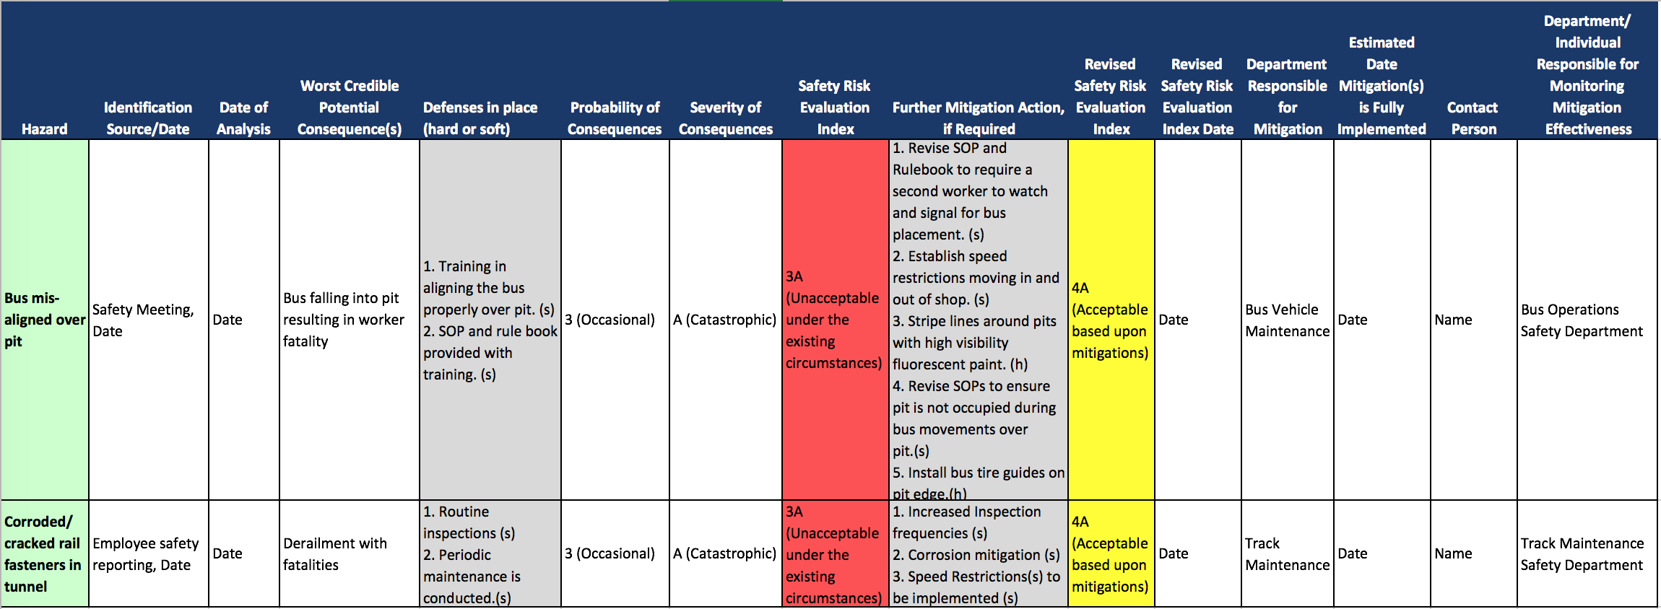

Table 2: Transition to Safety Assurance
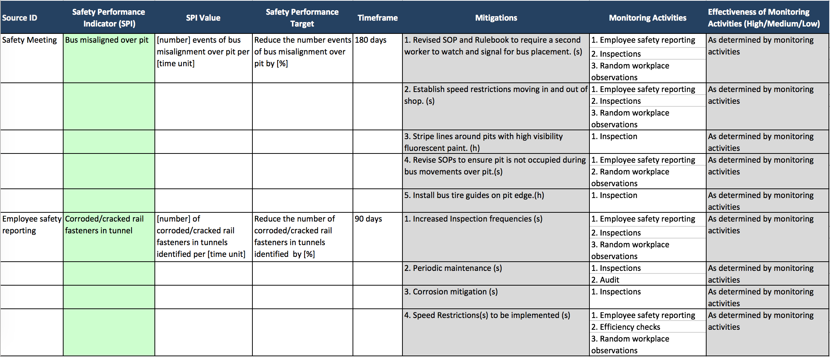

Tables 3-5: Safety Risk Tables and Index

Probability of Occurrence of the Consequence
Qualitative Definition | Meaning | Value
Frequent | Likely to occur frequently (>10⁻¹) | 1
Probable | Likely to occur several times (<10⁻¹ but >10⁻³) | 2
Occasional | Likely to occur sometime (<10⁻³ but >10⁻⁶) | 3
Remote | Very unlikely to occur (<10⁻⁶ but >10⁻⁸) | 4
Improbable | Almost inconceivable that the event will occur (<10⁻⁸) | 5

Severity of the Consequence
Definition Category | Meaning | Value
Catastrophic | - Equipment destroyed  - Multiple deaths | A
Critical | - A large reduction in safety margins, physical distress or a workload such that the operators cannot be relied upon to perform their tasks accurately or completely  - Serious injury  - Major equipment damage | B
Marginal | - A significant reduction in safety margins, a reduction in the ability of the operators to cope with adverse operating conditions as a result of increase in workload, or as a result of conditions impairing their efficiency  - Serious incident  - Injury to persons | C
Negligible | - Nuisance  - Operating limitations  - Use of emergency procedures  - Minor incident  - Little consequences | D

The requirement for minimum standards for operations was authorized under the Fixing America’s Surface Transportation Act (“FAST”) (Pub. L. 114-94 (2015)). The FAST Act supersedes MAP-21 and was signed into law by the President on December 4, 2015.
FTA's adoption of SMS means that it will give priority in its rulemaking, enforcement, oversight, and resources towards those issues that pose the highest risk to the safety of public transportation systems.
For more information on SMS, please visit FTA's SMS webpage at http://www.fta.dot.gov/tso_15176.html.
80 FR 48794, August 14, 2015. The Public Transportation Safety Program NPRM is available at http://www.gpo.gov/fdsys/pkg/FR-2015-08-14/pdf/2015-20021.pdf.
80 FR 11001. The SSO NPRM is available at http://www.gpo.gov/fdsys/pkg/FR-2015-02-27/pdf/2015-03841.pdf.
http://www2.census.gov/library/publications/2011/compendia/statab/131ed/tables/trans.pdf. Includes motor bus, commuter rail, heavy rail, light rail, demand response, van pool, and automated guideway.
The FHWA rules include the Federal-aid Highway Performance Measure Rules [RIN 2125–AF49, 2125– AF53, 2125–AF54], updates to the Highway Safety Improvement Program Regulations [RIN 2125–AF56], and Federal-aid Highway Risk-Based Asset Management Plan Rule for the National Highway System (NHS) [RIN 2125–AF57].
80 FR 58912.
Section 5329(b) requires the establishment of safety performance criteria, where other sections use the term performance measures. To maintain consistency and measurability, criteria are performance measures toward which transit agencies’ performance will be measured and targets will be set.
Note, for purposes of this Plan, FTA has interpreted “criteria” and “standard” to have the same meaning.
"Reportable" means the following information that is reported to the NTD: A safety or security incident occurring on transit property or otherwise affecting revenue service that results in one or more of the following conditions: • A fatality confirmed within 30 days of the incident; • An injury requiring immediate medical attention away from the scene for one or more persons; • Property damage equal to or exceeding $25,000; • An evacuation for life safety reasons; or • A mainline derailment. Also, in the SSO final rule and all future safety rulemakings we are defining “reportable accident/incident” in terms of injuries as: A report of a serious injury (Accident). OR A personal injury that is not a serious injury; one or more injuries requiring medical transport (Incident). Serious injury means any injury which: (1) Requires hospitalization for more than 48 hours, commencing within 7 days from the date of the injury was received; (2) results in a fracture of any bone (except simple fractures of fingers, toes, or nose); (3) causes severe hemorrhages, nerve, muscle, or tendon damage; (4) involves any internal organ; or (5) involves second- or third-degree burns, or any burns affecting more than 5 percent of the body surface.
Table 3-1 illustrates the types of information that is currently collected by the transit industry to measure its safety performance.
FTA and States should establish baselines for the performance measures within their SMS programs, as well.
Adapted from Guidance Notes on Safety Culture and Leading Indicators of Safety. American Bureau of Shipping (ABS), page 3. Available at http://www.eagle.org/eagleExternalPortalWEB/ShowProperty/BEA%20Repository/Rules&Guides/Current/188_Safety/Guide
Exceptions exist for small, rural transit agencies.
Initially, some agencies may use output measures, such as the number of vehicles inspected, or the percentage of employees who have completed safety training. Outcome measures are useful for establishing benchmark performance and setting targets.
79 FR 31784 (June 2, 2014).
These standards do not apply to heritage and vintage streetcar systems, inclined planes, cable cars, or monorails/automated guideway systems, nor do they apply to bus or paratransit service, though FTA reserves the right to issue subsequent regulations to these vehicles and their safe operation.
WMATA’s Ft. Totten crash, June 22, 2009; WMATA’s Woodley Park/Adams Morgan crash, November 3, 2004, and MBTA’s Newton Green Line crash, May 28, 2008.
http://files.asme.org/Catalog/Codes/PrintBook/28205.pdf.
http://files.asme.org/Catalog/Codes/PrintBook/28205.pdf.
http://standards.ieee.org/findstds/standard/1482.1-2013.html.
http://www.apta.com/resources/standards/Documents/APTA-RT-VIM-S-020-10.pdf.
http://www.apta.com/resources/standards/Documents/APTA-RT-VIM-S-021-10.pdf.
http://www.apta.com/resources/standards/Documents/APTA-RT-VIM-S-022-10.pdf.
http://catalog.nfpa.org/2014-NFPA-130-Standard-for-Fixed-Guideway-Transit-and-Passenger-Rail-Systems-P1229.aspx?icid=B484.
http://www.fta.dot.gov/documents/NASFM_Recommended_Practices.pdf.
80 FR 36 112. The Bus Testing NPRM is available at http://www.gpo.gov/fdsys/pkg/FR-2015-06-23/pdf/2015-14176.pdf.
http://www.apta.com/resources/standards/Documents/APTA-RT-OP-S-017-11.pdf.
http://www.apta.com/resources/standards/Documents/APTA-RT-OP-S-016-11.pdf.
http://www.apta.com/resources/standards/Documents/APTA-RT-OP-S-004-03.pdf.
http://www.apta.com/resources/standards/Documents/APTA-RT-OP-S-010-03.pdf.
http://www.apta.com/resources/standards/Documents/APTA-RT-OP-S-011-10.pdf.
http://www.fta.dot.gov/13099.html.
https://safety.fta.dot.gov/.
The terms in the Glossary may vary from the definitions of these same terms in FTA Safety regulations. They are provided in this Glossary for the reader’s use in understanding the principles and methodologies of Safety Management Systems.
The Hazard Register is also available as a Microsoft Excel Workbook on the TSO page of the FTA website at http://www.fta.dot.gov/.

