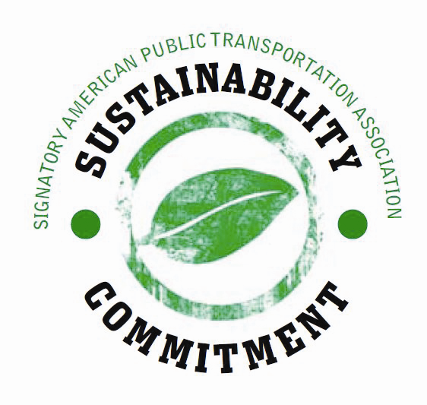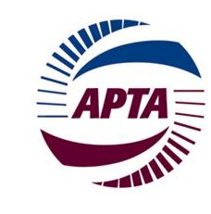

Help APTA tell its sustainability story by telling us yours. Take a few minutes to briefly answer these questions about how you’re supporting APTA’s sustainability commitment within your organization.

- Why was it important for your organization to sign the Sustainability Commitment?

- What has changed at your organization since signing the commitment?
- How have you communicated your commitment to sustainability to your employees / customers / the broader community?

- If you have signed the Sustainability Commitment but have not yet filed for advanced certification, what have been the obstacles or challenges to filing?

- If you haven’t signed the commitment yet, briefly tell us why.

Thanks. We’d like to share your story, so please provide some contact information.

Name:
Organization:
Title:
Phone:
Email:

