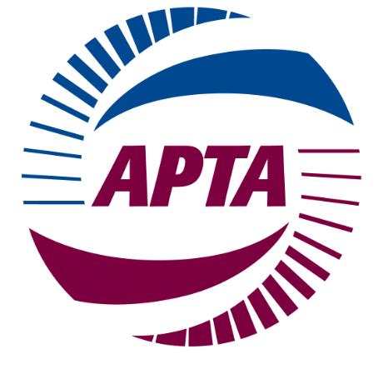
APTA 2014 ANNUAL MEETING & EXPO
PUBLIC-PRIVATE PARTNERSHIPS COMMITTEE
Hilton Americas Hotel
Ballroom of the Americas A, 2nd Floor
Sunday, October 12, 2014
8:00 - 9:30 a.m.
Houston, TX

AGENDA

- Welcome and Introductions - Mike Schneider, Chair

2. Update on U.S. DOT/U.S. Treasury “Build America Investment Initiative”
- Bob Tuccillo, FTA Associate Administrator for Budget and Policy

(Link below to summary report)
http://www.treasury.gov/press-center/press-releases/Documents/Expanding%20our%20Nation's%20Infrastructure%20through%20Innovative%20Financing.pdf
3. Subcommittee Reports
Policy and Legislation - Sharon Greene
- Findings and Recommendations of the Special Panel on Public-Private Partnerships,
Committee on Transportation and Infrastructure, U.S. House of Representatives

(Link below to summary report)
http://transportation.house.gov/uploadedfiles/p3_panel_report.pdf

Best Practices - Brian Middleton

Global Activities - Raul Bravo

Programs - Jeff Ensor
- APTA Annual Meeting Sessions:

"Innovative Funding Ideas for Public Transportation: Practices in National and International Revenue Development"
Monday, October 13, 2014; 3:30 - 5:30 p.m.
Convention Center Room 310

"Above the Din of the Deal: Comprehensive Finance Approaches to Advance Public
Transportation Projects"
Tuesday, October 14, 2014; 1:30 - 3:30 p.m.
Convention Center Room 360 ABDE

4. Follow-up: International Practicum on Innovative Transit Funding & Financing
- Draft summary notes
- International Study Mission

5. National Center for Innovative Transportation Finance - Art Guzzetti

6. Discussion of PPP Committee Scope and Focus

7. Remarks by APTA Chair Phil Washington & President & CEO Michael Melaniphy

8. Appointment of New Committee and Subcommittee Chairs

9. Other Business

10. Next Meeting: Sunday, March 8, 2015 (in conjunction with APTA Legislative Conference)

11. Adjourn

