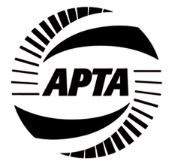

AMERICAN PUBLIC TRANSPORTATION ASSOCIATION

TRANSIT BOARD MEMBERS COMMITTEE

The Hilton Americas Hotel in Houston, TX.• Lanier Grand Ballroom A

Sunday, October 12, 2014 • 1 – 2:30 p.m.

PROPOSED MEETING AGENDA

- Welcome & Introductions– Dr. Valarie J. McCall, committee chair

- Vice Chair Report & Legislative Update – Randall D. Chrisman, vice chair

- Approval of minutes, July 19 meeting – David Stackrow, secretary

- Board Support Subcommittee Update – Beth Vidaurri, subcommittee chair

- Safety Culture Presentation “Community Policing with a Focus on Operator Safety & Security” – Chief John Joyce, Chief of Police , Greater Cleveland RTA
- Q & A Safety Discussion

- Invitation to 2015 Transit Board Members Seminar - Angie Rivera-Malpiede, Director, RTD Denver

TBM Subcommittee Meetings

Sunday, October 12
TBM Legislative Subcommittee – 3 – 4p.m., Room 344, Hilton Americas Hotel

Monday, October 13
TBM ADA Subcommittee – 1 – 2 p.m., Room 342CF, George R. Brown Convention Center

Attachments:
- Minutes, July 19 Meeting
- Roster, Executive Council, Transit Board Members Committee

