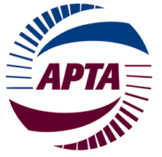
Safety Coordinating Committee Meeting
Sunday, March12, 2017 - 8:30 AM – 10:00 AM
JW Marriott
1331 Pennsylvania Ave NW, Washington, DC
Room: Commerce

AGENDA
- Opening Safety Briefing – Gerry Ruggiero, Chair
- Welcome and Introductions Around the Room

- Gerry Ruggiero, Jacobs Engineering

- Randy Clarke, VP Operations and Member Services

- APTA Update

- Introduction of new APTA Safety Director

- Brian Alberts

- Safety Coordinating Council Plan, Board of Directors Meeting Safety Highlights
- Gerry Ruggiero, Jacobs Engineering

- Randy Clarke, VP Operations and Member Services

- Audit Program

- Randy Clarke, VP Operations and Member Services

- Mid-Year Meeting - Decision
- Gerry Ruggiero, Chair

- Update on Bus and Rail Safety and Awards

- Randy Clarke, VP Operations and Member Services

- Federal Update?

- Roundtable

- Go around the room and bring up issues of concern

