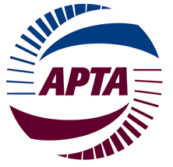

APTA Commuter Rail CEO Committee
Sunday, March 12, 2017 – 12:30 PM – 3:30 PM
JW Marriott
1331 Pennsylvania Avenue NW, Washington, DC
_______________________________________________________________________________

Agenda

- Lunch

- Safety Briefing

- Introductions

- Committee By-Laws Review

- Recap of CEO Retreat

- PTC Update and Survey

- Sleep Apnea Update and Discussion

- Government Affairs Update (Congress/Administration)

- Appropriations
- Infrastructure Package
- Buy America

- Regulatory Update

- CEO Discussion

